Queensland Kindergarten Funding (QKF)

QKF governance and assurance
Queensland Kindergarten Funding (QKF)
z
The department is committed to ensuring that the funding provided enables all children to have a strong start through greater access to a quality kindergarten program for Queensland children, improving inclusiveness and reducing out-of-pocket fees for many families.

Governance
Approved providers have overall responsibility to comply with the legislative provisions of the Community Services Act 2007 (CSA), under which funding is granted for individual or multiple long day care services or through a Central Governing Body (CGB) for sessional kindergartens. Approved providers should implement appropriate governance practices to meet these obligations, including adherence to:
- accurate submission of claims including agreement to the Kindergarten Funding Terms and Conditions
- reporting requirements (including provision of information/documentation to the department)
- compliance with the 2023 Kindergarten Funding: Funding Category Guidelines and the QKF Essentials, including all child/service eligibility and other operational requirements
This is essential for initial application and ongoing submission of claims.

What is assurance?
Assurance in this context, is referred to as appropriate actions to safeguard funding for the delivery of products or services, in particular to ensure compliance with the CSA and QKF Essentials in the proper and efficient delivery of funded products and services.

What is an assurance review?
Assurance reviews will be scheduled periodically to assist the department, as the funding provider, to monitor the appropriation of funds in line with the guiding principles of the CSA and obligations under the Financial Accountability Act 2009.

What reviews are conducted?
A variety of reviews across Queensland are conducted based on initial analyses of claims submitted and may include a review of one or more subsidies, eligibility criteria and/or requirements. This will enable essential coverage in an effort to drive consistent and accurate claims, with appropriate expenditure of subsidies.

What is a corporate controls survey?
As part of a review, in particular for larger organisations that operate multiple services, a corporate controls survey may be requested to be completed to demonstrate appropriate governance strategies for maintaining compliance, including items such as workforce, recordkeeping and financial accountability.

What are the actions taken following a review?
On completion of a review, an Outcome Report will be provided, detailing the findings and any improvement strategies such as educational support/ resources, or identify further actions to be taken, including recovery of funds.

Who is part of the review?
Authorised Officers undertake reviews as part of their role under the CSA. The Authorised Officer will contact the approved provider to initiate the review process, requesting documentation for determining a services compliance with the selected criteria. On occasions it may be appropriate to undertake a site visit as part of an assurance review.

What is an Authorised Officer?
An Authorised Officer is appointed under the CSA to undertake certain functions relating to funding including investigating, monitoring and ensuring compliance with the CSA.

What are the powers of Authorised Officers?
Powers enable Authorised Officers to undertake prescribed functions to determine compliance, including requesting information/ documentation and entering a place (announced or unannounced).

False or misleading information
It is imperative that accurate and up-to-date records are retained to support each kindergarten funding claim and is provided on request. Under s48 and s49 of the CSA a person must not state, or give documentation, that they know is false or misleading.

Recovery of funding
Funds will be recovered in instances where the service does not meet the criteria/requirements and/or cannot provide evidence to demonstrate compliance, e.g. no qualified early childhood teacher delivering the approved kindergarten program. These funds will be recovered as a debt owing to the department and future funding may be suspended or terminated, in accordance with the QKF Essentials.

Compliance actions
Depending on the outcomes identified from a review, appropriate actions will be taken. Failure to meet the funding criteria or requirements may result in further compliance action being initiated such as a compliance notice or show cause with a potential consequence of suspending or stopping funding.

Assurance reviews in 2023 (based on 2022 claims)
Approved providers in receipt of kindergarten funding have an ongoing obligation to adhere to the eligibility criteria, operational requirements and terms and conditions. Records demonstrating compliance are required to be provided on request by the department including for the purposes of an assurance review. This includes, for example, recording each quarter how the standard subsidy has been used and retaining evidence of the spending in a dedicated kindergarten file.
For assurance reviews in 2023, there are four focus areas for the department. These are based on previous trends, in ensuring ongoing compliance and appropriate application of QKF subsidies. Further information regarding the key focus areas is available on the department’s website.

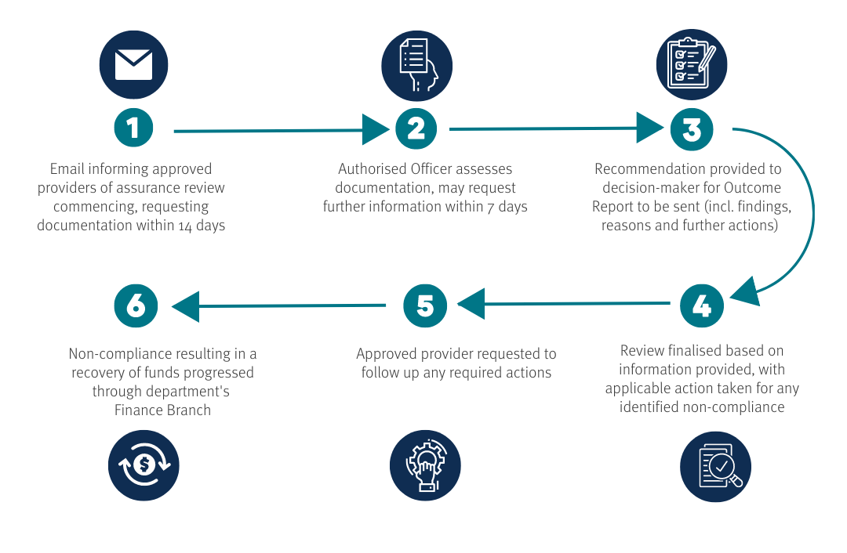
Participating in an assurance review

Checklist
To assist in preparing the return of your documentation when participating in assurance reviews based on 2022 claims, the below sample checklist has been developed.
Subsidy/  requirement | Example evidence  (Dependant on what is required to demonstrate compliance) | Have you attached?
Information request | Completed information gathering form | ☐
ECT qualifications | Completed ECT information and qualification form for each ECT engaged to deliver the approved kindergarten program | ☐
 | ECT qualifications as listed on the ACECQA website and academic transcript showing any applicable study majors | ☐
 | Teaching qualifications, teacher registration/accreditation and approved certificate III level or higher qualification | ☐
 | ACECQA approval letter confirming equivalence of ECT qualifications | ☐
 | QKFS Teacher Recognition letter supplied by the Department of Education and teacher registration (if required) | ☐
 | Working towards ECT - Current academic transcript identifying all completed and enrolled subjects and an approved diploma level qualification (if required) | ☐
Standard Subsidy | Completed expenditure table with applicable calculations | ☐
 | Receipts (e.g. children’s/ECT resources, ECT professional development and extracurricular activities) | ☐
 | Calculations completed for fee reduction, with supporting fee structure, reports and family fee statements | ☐
 | Calculations completed for ECT improved entitlements, with supporting ECT payslips/employment contract | ☐
ARIA | Receipts (e.g. relocation costs, accommodation costs, flights, ECT professional development and any applicable study support costs) | ☐
 | Calculations completed for ECT improved entitlements, with supporting ECT payslips/employment contract | ☐
SEIFA | Calculations completed for fee reduction, with supporting fee structure, family fee statements and CCMS software report | ☐
QKFS Plus | Fee structure, family fee statements and CCMS software report | ☐
Kindy Uplift | Approved Kindy Uplift Plan identifying applicable funds expenditure | ☐
 | Receipts (e.g. professional development, resources and programs), payslips and service rosters | ☐
Ages of children | Room rolls for kindergarten cohort with dates of birth | ☐
Hours of delivery | Room rolls with dates of birth, service rosters and daily kindergarten program routine | ☐
QKLG | Programming and planning with reference to the QKLG | ☐
Transition statements | Confirmation of portal submission and sample of transition statements using the approved template | ☐
Workforce plan | Workforce plan identifying service specific workforce strategies | ☐

