Review of the 2011–2014 Early Childhood Education and Care
Workforce Action Plan

Leadership Capability Development research project

With the 2011–2014 Early Childhood Education and Care Workforce Action Plan (WAP) in its final year in 2014, a review was undertaken to assess what had been achieved under the plan, and to inform future early childhood education and care (ECEC) workforce development strategies. A research project – the Leadership Capability Development Project – was undertaken as part of this review.

Conducted on behalf of the department by the Health and Community Services Workforce Council (Workforce Council) between July and December 2014, the aim of the project was to:
- review existing best practice in leadership capability development and support
- pilot a model of leadership capability development in early childhood education and care settings
- provide recommendations for the future delivery of an effective leadership development model.

The pilot took an action research approach, focusing on leadership capability development through an inter-sectoral mentoring program. The program provided professional development for participants in areas such as interpersonal skills, leading people, and addressing attitudes and beliefs about leadership.
The project worked with and leveraged from the Workforce Council’s existing leadership-related program:
- Skills clusters program, which addresses individual level skill gaps in leading and managing change, human resource practices, and coaching and mentoring
- Sector leadership strategy, which focuses on sector level change by enabling individuals in leadership roles to take responsibility for sharing ideas and learnings with local and statewide networks.

How was the research conducted?

The research project was conducted using:
- a desktop review of research and best practice in early childhood education and care leadership capability development and support both locally and nationally.

- piloting of the mentoring model which involved:
- 86 mentors and mentees in three locations (Logan, Caboolture and Townsville)
- three days of face-to-face advanced practitioner workshops focusing on developing mentors’ skills, knowledge and capabilities in relation to mentoring and leadership
- two 2-hour online sessions providing support and opportunities to reflect on progress and make goals for the future
- coaching sessions with mentees to fine tune understanding, address challenges and evaluate progress.

Mentors and mentees were identified and matched through an expression of interest process, and participants were drawn from long day care, family day care, outside school hours care and kindergarten services. The pilot ran from July to November 2014. Of the 86 total participants, three dropped out over the life of the pilot.

Methods for gathering data from mentors and mentees to evaluate the model included:

- online surveys
- scale activities (self-assessment) at the beginning and end of the pilot
- qualitative data collection through the coaching sessions
- surveys conducted at the end of the pilot and four weeks post-pilot.

Feedback was also sought from staff in participating services who were witness to changes in the leadership capability of mentors and mentees, to assist in measuring service and sector level change.

What were the key research findings?

Philosophy for effective professional development
The research review indicated that the knowledge and abilities of leaders in early childhood education and care settings impact not only on the educators working in such services, but also on the children and families from communities in which the services are operating. Programs that effectively support the development of leadership capabilities in areas such as interpersonal and communication skills, and develop increased knowledge of leadership and management tools and processes, are essential to ensure the delivery of quality early childhood education and care services for children and families.

The evidence reviewed suggested that adult learners experience the greatest growth when they are able to undertake learning over an extended period of time. A person’s reflection on, and assessment of, their own learning, along with the provision of opportunities to apply new knowledge and skills, are optimal for effective learning.

As a result of the research, the Workforce Council has developed a philosophy for the delivery of professional development that is most likely to result in positive, sustained practice change. The key components of the philosophy are depicted in the diagram below.

Learning that extends over time
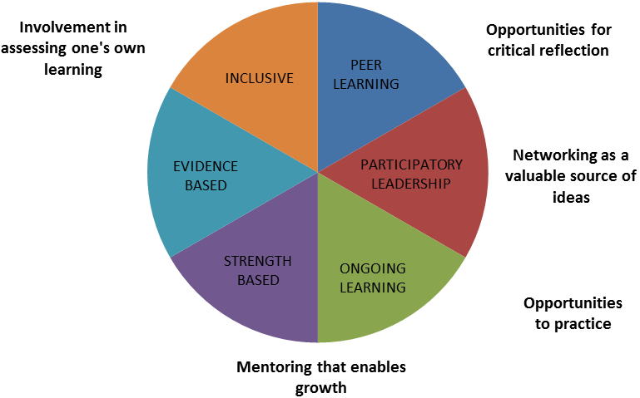
Investigating real life examples in one’s own setting
Creating space for conversation and sharing to deepen understanding

The Leadership Capability Development Project, working alongside the other leadership programs, ensured these best practice characteristics of learning were incorporated into the piloted model. The outcomes for mentors and mentees, as described below, support the effectiveness of these principles in supporting practice change.

Data limitations
Survey response rates were not optimal, ranging from 25% for mentees and up to 50% for mentors. Although these rates combined with an acceptable response rate of 60% for the coaching sessions and interviews provide some robustness to the data, it is important to consider such limitations when interpreting the project outcomes.

Project outcomes
The impact of the model was measured at the individual (e.g. leadership practice, attitudes and beliefs, thinking and knowledge), service (e.g. culture, group knowledge and sharing, and relationships within the service) and sector (e.g. professional culture, sector knowledge sharing, and professional relationships) levels.

Tangible outcomes
Tangible outcomes refer to actual products produced, new strategies/methods utilised, or deliberate changes made which mentors or mentees have reported as directly resulting from participation in the project.

The project’s greatest impact on the leadership skills of participating mentors and mentees was under the themes leadership and teams and programming and practice. For mentors, significant changes were also reported in the areas of career progression/pathways and management tools and strategies.

‘We have changed some of the rules in the service that were restricting people – we realised we can make the changes ourselves and this is more freeing. The team culture has changed. As a leader, I feel more natural and open to working with others.’ (Mentor outcome – Leadership and teams).

‘I am now working in the rooms more, asking questions, highlighting the needs for reflection, and training the leader to do this too. Staff are now more hands on with the children.’ (Mentee outcome – Programming and practice).

Transitional outcomes
Transitional outcomes are those which are more complex and dynamic, and which resonate at the individual, service and sector levels. These outcomes reflect systemic and interconnected layers of change which occur as an individual experiences change, which then leads to change as a service and, in turn, at the sector level.

Mentors
At the individual level, mentors indicated participation in the project resulted in changes in attitudes and beliefs, leadership practice and relationships with others. Enhanced skills in active listening and increased reflection on their own practice as leaders were the most significant changes reported by mentors.

‘I didn’t expect the project to have such an impact on my confidence.’ (Mentor outcome – Attitudes and beliefs).

‘I feel that my mentee now has the support they need to change and is focussed on continual improvement.’ (Mentor outcome – Thinking and knowledge).

At the service level, the greatest change for mentors was with regards to their increased likelihood to prepare more effectively to grow and exchange ideas within their services. In addition, a large number of mentors indicated changes to the way in which they are working are having flow on effects on how educators in their services are now engaging with others.

‘I used to loathe the things like the QIP, but with more self-reflection and seeing the benefit in setting goals and continuous improvement of self, I now see the benefits of things like the QIP. It’s for our benefit’. (Mentor outcome – Service culture).

Mentees
At the individual level, mentees reported their knowledge and understanding of professional learning and reflective conversations, along with the application of skills in setting clear goals and providing constructive feedback, were most positively impacted by their participation in the project.

At the service level, they identified significant changes in relation to motivation to commit to continuous learning and involve others in decisions.

‘I have consistently questioned my own practices, why I do what I do and how I can improve those practices to achieve the goals in my QIP and then progress them, adding another dimension to work on achieving.’ (Mentee response – Service culture).

Service and sector outcomes
Both mentors and mentees identified some key changes resulting from the project which were, at the time of the project, already impacting their service. These included a greater understanding of the mentoring role and the impact it can have on supporting people across the early childhood education and care sector.

‘My most significant learning was that I see mentoring as a very valid and useful way to support someone.’ (Mentor response – Professional knowledge and sharing).

More than three quarters (78%) of mentors and mentees indicated that they intend to continue the mentor/mentee relationships established through the project.

‘I will continue this mentoring relationship because we have been mutually benefitted by the professional relationship and this will continue.’ (Mentee response – Professional relationships).

Feedback from individuals external to the project (e.g. colleagues and management committee members) reported the most noticeable changes observed among mentors and mentees were in regards to increased levels of confidence, enhanced leadership and communication skills (e.g. better communication with staff and families), and greater approachability for staff and families.

Sector level change was difficult to quantify at the time of evaluation due to the length of time it takes for practice change to filter down to significant changes in service and sector culture and practice.

Factors impacting on learning and participation
Mentors rated their own personal motivation levels and the degree of support provided to them from within their service as having a significant impact on the learning outcomes achieved as a result of the project.
Mentor/mentee fit was rated as having the greatest impact on outcomes for mentees, along with their understanding of their role within the project.

While the time available to participate in the project was not reported as having a significant impact for most mentors and mentees, it was the area in which mentees and mentors vocalised the most dissatisfaction.

Conclusions and recommendations

The results of the pilot of the mentoring model confirm that ongoing experiential learning activities result in practice change. For mentors, the leadership capability development model enhanced their own leadership skills, including skills in participatory leadership. The major learnings for mentees were in the areas of leadership (i.e. leading staff and relationships) and programming and practice.

The project identified a number of learnings that can inform future mentoring models:
- Greater time and investment incorporated into the initial phase of the model, followed by a longer period of independent and self-directed mentoring.
- Role clarification for both mentors and mentees addressed in greater detail in the initial stages of the model and clearly articulated in the expression of interest for participation.
- The expression of interest should clearly articulate project requirements regarding the necessary time commitments and highlight that participation should be voluntary.
- Strategies should be put in place to ensure organisational support for mentors and mentees through conversations regarding time, space, encouragement and involvement prior to the commencement of participation in the model.
- Travel and accommodation support could be continued and extended to support mentees to visit mentors.
- All financial support should be linked to attendance and participation, and be delivered upon completion of participation in the model.

The project found that a mentoring model that brings together participants from across service types and geographic locations can complement and add value to the leadership development work undertaken by individual providers. It recommended that early childhood education and care leaders be supported to participate in a variety of leadership focused professional development experiences, depending on the specific outcomes they are trying to achieve and their level of experience.

The research recommended that any future mentoring approach should be implemented in an integrated way with related leadership strategies to ensure all opportunities to value add or leverage from other modes of service delivery are fully explored. A staged approach was suggested, with educators able to access a range of support at different levels, from professional developed aimed at developing specific skills, through a mentoring-based approach to ongoing learning, and on to sector-level networking, advocacy and leadership opportunities.

The findings of this research will be used to inform future ECEC workforce development strategies, including the development of a new 2015-2018 ECEC Workforce Action Plan.

For more information
Please visit the dedicated WAP review page on the department’s website at www.dete.qld.gov.au/earlychildhood/WAPreview.

