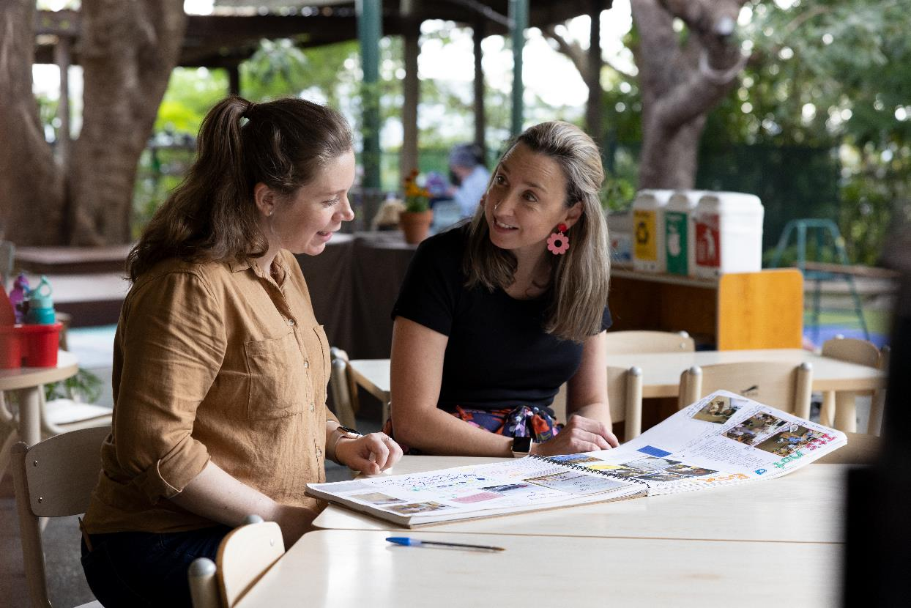

Kindy Uplift 2026

Advisory Support Guide

z

Acknowledgement of Country
The Department of Education (the Department) acknowledges the Traditional Owners of the lands from across Queensland. We pay our respects to the Elders past, present and emerging, for they hold the memories, the traditions, the culture and hopes of Aboriginal peoples and Torres Strait Islander peoples across the state.
A better understanding of and respect for Aboriginal and Torres Strait Islander cultures develops an enriched appreciation of Australia’s cultural heritage and can lead to reconciliation. The Department has made a commitment to place Aboriginal peoples and Torres Strait Islander peoples at the forefront of decision-making in the spirit of reconciliation. Creating supportive environments where stakeholders feel empowered to act, allows our agency to move collectively in the same direction.

Advisory support overview
Advisory support is provided within the Kindy Uplift program to guide and mentor service staff to plan, utilise and implement Queensland Government kindergarten funding in ways that uplift the kindergarten program, build teacher and educator capability and support better outcomes for Queensland children. All Queensland kindergarten services that are delivering an Approved Kindergarten Program and are participating in the Kindy Uplift program, are expected to engage with advisory support.
Advisory Support Organisations are to work closely with services in receipt of Kindy Uplift funding. This involves:
- supporting services with Kindy Uplift planning including collection and analysis of data, identifying goals and priorities and engaging providers,
- facilitating connections between services with similar goals and priorities to maximise funding opportunities,
- providing ongoing support through implementation to ensure successful program outcomes, and/or
- working with services to undertake critical reflection and evaluation of outcomes.
Advisory support is aligned to the following key departmental and sector priorities:
- Culturally safe, inclusive and responsive kindergarten programs
- Workforce initiatives
- Practice improvement initiatives.

Culturally safe, inclusive and responsive kindergarten programs
Culturally safe, inclusive and responsive kindergarten programs demonstrate a genuine commitment to:
- embedding Aboriginal and Torres Strait Islander perspectives, and
- equity and access for all.
Embedding Aboriginal and Torres Strait Islander perspectives through Kindy Uplift, should be data-informed and responsive to the needs of the current Kindergarten cohort, ensuring continuous improvement and building greater cultural safety and capability in all Queensland kindergarten programs.
Advisory Support Organisations are required to employ an Aboriginal or Torres Strait Islander person or ensure strong partnerships with appropriate Aboriginal or Torres Strait Islander organisations to guide and support the development of culturally safe, inclusive and responsive kindergarten advisory support in regard to Kindy Uplift.
Aligned with culturally safe, inclusive and responsive kindergarten programs, the role of advisory support includes:
- encouraging services to be culturally responsive in everyday practices and developing teachers and educators’ own cultural knowledge and connections,
- supporting and advocating for services to adopt culturally responsive approaches specific to their families and their community context,
- advocating for services to cultivate culturally safe environments,
- fostering local connections and networks that support ongoing growth and reflection on embedding Aboriginal and Torres Strait Islander perspectives,
- supporting services to strengthen capability using strategies to critically reflect on current pedagogies and practices to ensure they are inclusive and free from bias, and
- working with the department to promote access to available resources, subsidies and initiatives which support inclusion ready services and confident capable teachers and educators working with children who have diverse and/or complex needs.

Workforce initiatives

Workforce building and development, qualification progression and leadership capabilities
Teachers and educators are essential in helping every child begin with a strong foundation and reach their full potential. Workforce initiatives strengthen the early childhood sector by ensuring teachers and educators are empowered, prepared, confident, and supported to meet the diverse needs of every child. They provide opportunities for educators to grow their expertise and progress their careers through tailored support and access to contemporary training and flexible career pathways. These initiatives also foster excellence, while helping build, sustain and support a workforce that reflects the children and the communities they serve. Advisory support plays a pivotal role in supporting workforce initiatives within the kindergarten sector.
Aligned with workforce initiatives, the role of advisory support includes:
- supporting teachers and educators to identify professional development opportunities and sustainable strategies for embedding professional learnings into practice,
- working with the department to promote workforce qualification assistance grants and scholarships for early childhood professionals to attain or upgrade early childhood qualifications,
- providing and promoting mentoring and coaching opportunities to foster continuous improvement, qualification progression and leadership coaching,
- enabling and enhancing teacher and educator connection to local support networks, and promoting collaborative approaches.

Practice improvement initiatives

Data literacy
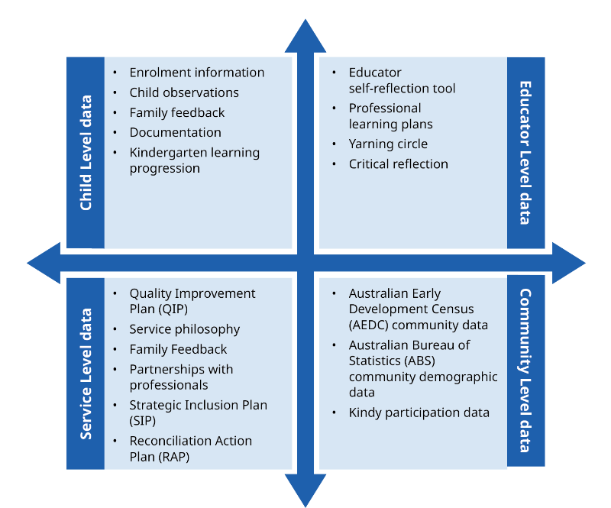
Data literacy is the ability to read, understand, communicate and use data as a meaningful source of information. It involves knowing the sources of data available to us, analysing and interpreting that data to make informed judgements and take appropriate actions. In early childhood education and care settings, data literacy can assist our understanding of factors impacting children’s learning, define responsive practices and enable quality improvement priorities. The below diagram lists some examples of data sources.

Data should always be collected ethically, respecting and maintaining the rights of the child, families, teachers and educators and the community. Teachers and educators should engage intentionally and collaboratively with data, focusing on solutions in an ethical and inclusive manner. Data evidence supports teachers and educators to identify the strengths and educational needs of the service.
Aligned with data literacy, the role of advisory support includes:
- supporting services to access various data sources which may include, but is not limited to, Australian Early Development Census (AEDC), Australian Bureau of Statistics (ABS) community demographic and Kindy participation data,
- encouraging teachers and educators to identify relevant types of data which may include, but is not limited to, the services Quality Improvement Plan (QIP), Reconciliation Action Plan (RAP), Family feedback, enrolment information, child observations, documentation, educator self-reflection tool, professional learning plans and critical reflection to inform data analysis,
- collaborating with teachers and educators to understand their current data-informed practices, identify gaps, and determine specific areas where improvement is needed,
- supporting teachers and educators to engage in collaborative conversations about how to transform data insights into actionable strategies relating to identified priorities,
- providing opportunities for teachers and educators to engage in professional development, professional conversations and networking meetings to enhance data literacy skills and knowledge, and
- facilitating and promoting workshops to promote data literacy, knowledge of data sources, tools for collecting and analysing data, and communicating data to share meaningful information and implement quality improvement strategies.

Professional learning opportunities
Professional learning is important for the continuous growth of teachers and educators’ practice and is pivotal to the quality improvement journey for services. Kindy Uplift supports continuous practice improvement through expert-led and peer-led professional learning opportunities. The service’s QIP can be used to support Kindy Uplift planning against the priority areas. Kindy Uplift planning must be included in the service’s QIP or another service planning document.
An expanded view on professional learning acknowledges the varied forms of practice that contribute to enhancing outcomes for children. For example, this may include bi-cultural supports, peer-led mentoring within their service, critical reflection on peer learnings and expert knowledge.
The department encourages services to engage in sustained practice improvement strategies such as co-planning with experts, periodic coaching and continuous plan reflection. Research suggests one-time professional learning sessions can be ineffective in driving practice change.
Aligned with professional learning opportunities, the role of advisory support includes:
- supporting services to identify their professional learning needs and find solutions,
- championing a broader perspective on educator development advocating for an expanded view of professional learning by recognising there are many forms of practice uplift that can be achieved in a variety of ways,
- support services with collaborative Kindy Uplift planning, to inform continuous quality improvement, and identify opportunities for the focus of Collaborative Learning Communities and Collaborative Learning Opportunities,
- creating, engaging and enabling professional learning communities where teachers and educators can come together in a sustained way to discuss and analyse practices,
- working across services to offer workshops to deep dive on priorities and topics of shared interest, to build a strengthened and embedded approach to quality improvement,
- encouraging teachers and educators to engage in professional conversations and reflection after learning sessions, promoting critical reflection as an essential element of professional learning to help them integrate new practices and strengthen the evaluation of their programs,
- working with the department to promote workforce leadership initiatives for early childhood professionals, and
- supporting all teachers and educators to monitor children’s learning and development using the Kindergarten Learning Progression Tool where applicable.

Collaborative leadership
Effective collaborative leadership and teamwork involve leaders and team members working closely together, sharing ideas and making decisions as a group. It involves open communication, respecting each other’s contributions and combining strengths to achieve common goals.
Advisory support can facilitate services to build a positive work culture in order to achieve collaborative leadership and teamwork.
Aligned with collaborative leadership and teamwork, the role of advisory support includes:
- encouraging teams of teachers and educators to meet regularly and have professional discussions about children’s learning and development, and wellbeing,
- providing guidance around critically reflective conversations for individual and team professional growth, reflecting on service’s vision, values and statement of philosophy,

Assessment practices in early childhood
Advisory support can strengthen concepts of high-quality assessment in early childhood.
Assessment for children’s learning or formative assessment relates to information about what children know, can do and understand. Rich and meaningful information is gathered by teachers and educators to inform teacher and educator decision making about next steps for teaching and learning.
Aligned with assessment practices in early childhood, the role of advisory support includes:
- supporting use of the Kindergarten Learning Progression Tool with services utilising the progressions to inform next steps in learning for children,
- supporting teachers and educators to take a strength-based approach to children’s learning including culturally responsive and inclusive approaches to assessment practice,
- encouraging teachers and educators to have professional conversations about decision making and the use of intentional teaching strategies, observing children’s learning deeply, and collecting high quality evidence of children’s learning,
- supporting teachers and educators to moderate observations of children’s learning and development to gain different perspectives, insights and ‘where to from here’ ideas, and
- reflecting with teachers and educators about how children are involved in their own learning and documentation of learning.

Model of support
Advisory support will be tailored to the unique needs of participating services, acknowledging that some services may require more intensive assistance than others to achieve the desired outcomes. The level of advisory support should be guided by the following principles and adjusted throughout the year to accommodate the evolving needs of services:
- Service Needs: Align the level of support with the specific needs of each kindergarten, taking into account factors such as staff experience, qualifications and capability, and the community context.
- Performance and Outcomes: Service performance and outcomes identifying areas where additional support may be required.
- Emerging Challenges: Respond proactively to new challenges or circumstances that arise during the year, such as staffing changes, shifts in community needs, or unforeseen events.
- Collaboration and Feedback: Work closely with service providers to gather feedback and ensure that the support provided is both appropriate and effective.
- Flexibility: Adopt a flexible approach to adjust advisory support as needed, ensuring it aligns with changing priorities and delivers the best outcomes for children and families.
Services in receipt of over $80,000 will be supported by Advisory Support Organisations to adopt a community approach to increase positive outcomes for children at a community level.
Services without a qualified and experienced ECT should be prioritised for intensive advisory support.

Phases of Kindy Uplift
Each year Kindy Uplift follows a phased approach to implementation. In addition to key responsibilities above, advisory support includes supporting services through each Kindy Uplift phase. The four phases to Kindy Uplift include:
- Planning
- Payment of Funding
- Implementation
- Evaluation and reporting

Planning
Kindy Uplift planning can be undertaken at any time throughout the year. Kindy Uplift funding is provided to support the education needs of the current cohort of children and as such should be adaptable to the needs of the children within the cohort. All Kindy Uplift planning should be finalised for implementation by February 2026. This will enable a service to implement their plan as soon as they receive funding.
The role of advisory support during the planning phase includes:
- working with services to upskill data analysis capabilities,
- assisting services to identify appropriate data sources,
- assisting services to identify goals to achieve in their Kindy Uplift year identified by their data analysis,
- working with services to identify appropriate expenditure that complements the data analysis and goal identifications,
- advising services on in and out of scope funding items, and
- assisting services to complete their Kindy Uplift planning.

Payment of Funding
Services not aligned with a large organisation will receive funding in the first quarter of the year, provided they have:
- submitted an EdGrants application for the current year, and
- fulfilled any outstanding reporting obligations from previous years.

Implementation
During the implementation phase, services will begin undertaking planned Kindy Uplift activities. The role of advisory support during the implementation phase includes:
- supporting services to implement their Kindy Uplift planning,
- creating and facilitating Collaborative Learning Communities,
- facilitating Collaborative Learning Opportunities on common priorities or goals across services,
- encouraging reflective practice within services to reflect on capability development, and
- enabling cross service collaboration and connection to foster shared learning environments and continued practice change.

Evaluation and reporting
All Kindy Uplift services must complete a survey in April each year to provide feedback on the planning and implementation of the program. A second survey is required in November to evaluate progress and outcomes.
Regular reflection and evaluation through these surveys support continuous growth, adaptability, and informed decision-making, fostering sustained improvement across services.

Kindy Uplift - Key functions of advisory support
Key functions of advisory support include:
- developing productive relationships that empower teachers and educators to increase capability, meet Kindy Uplift priorities, include Aboriginal and Torres Strait Islander priorities, and support workforce development,
- supporting the completion, review and monitoring of evidence-based Kindy Uplift planning, in line with data knowledge, developmental priorities, evidence informed practices, milestones and timeframes and service quality improvement planning,
- providing sustained, consistent messaging, communicating expert knowledge and facilitating access to the department’s Kindergarten funding initiatives, practice frameworks, resources and tools,
- establishing, facilitating and engaging in Collaborative Learning Communities and Collaborative Learning Opportunities with services
- engaging with regional teams to leverage existing networks, Collaborative Learning Communities and Collaborative Learning Opportunities.

Collective advisory support

All participating services
Opportunities for participation in collective advisory support initiatives will be offered to all Queensland kindergarten services that have opted into Free Kindy and are delivering an Approved Kindergarten Program, alongside individualised service support. This includes enabling, facilitating and engaging in online or in-person Collaborative Learning Communities and Collaborative Learning Opportunities, as well as distributing information through newsletters or email communications.

Place-based approaches
The department advocates for advisory support to consider the needs of children and communities within holistic early years’ service delivery, and from a place-based whole-of-community approach to capability building and responsive practice supports. These approaches may include promoting Collaborative Learning Communities, Collaborative Learning Opportunities, working closely with regional partners in the department, engaging with Early Years Places, Family support and community and cultural organisations.

Collaborative Learning Communities
Collaborative Learning Communities are an effective way to bring together teachers, educators and key stakeholders who share a common priority, interest in a key topic, and/or a set of issues or challenges. They provide an opportunity to come together in a purposeful way, to discuss, problem solve, plan and fulfil both individual and group goals. Collaborative Learning Communities often focus on sharing innovative strategies and tools, combining efforts toward a common goal, and creating new knowledge to advance a domain of professional practice.
The role of advisory support includes coordinating Collaborative Learning Communities that focus on peer-led learning and reflective practice opportunities across organisations while engaging regional office representatives. The content of Collaborative Learning Communities is directed by the members involved, due to their specific needs throughout the year.

Collaborative Learning Opportunity

A Collaborative Learning Opportunity is a paid learning opportunity where services co-contribute funding or extend invitations to other services to attend professional learning experiences.

Services receiving over $80,000 of allocated funding
Services receiving over $80,000 will be supported by advisors to adopt a community approach. The role of advisory support includes working with these services to identify a relevant and bespoke community approach for their area. This could involve:
- funding professional development of common priority areas for all of the communities’ services to attend, or
- paying for flights and accommodation of specialists to visit the area attending to multiple services.

Supporting resources for kindergarten advisory support
- Kindy Uplift Planning documents
- Advisory Support Guide
- Online general information sessions
- Kindy Uplift videos
- Workforce Planning Modules
- Kindergarten Learning Progression Tool
- Cultural Capability Building

Glossary
Collective advisory support: Activities and initiatives that reach a group or collection of services simultaneously, this may include organisation wide, state wide, issue based or place based communications, Collaborative Learning Opportunities, Collaborative Learning Communities sessions.
Community approach: Thinking holistically about the early years’ service delivery footprint in the community and providing opportunities for all educators and people delivering early years programs to benefit from the funding so that they can better respond to children’s needs and support a positive transition to kindergarten.
Data: A collection of information gathered by observation, questioning or measurement, to be questioned, analysed and used to help with decision-making.
Embedding Aboriginal and Torres Strait Islander perspectives: Creating culturally safe places, working in intercultural ways through pedagogy and practice, engaging with Aboriginal and Torres Strait Islander peoples and authentically embedding perspectives in planning and implementation of curriculum.
Equity and access for all: Recognising and responding to the needs of children more likely to experience educational disadvantage within the service and community. This includes consideration to family diversity, cultural and linguistic differences and other barriers to meaningful engagement and participation.
Individualised service support: Support and communication that is targeted to an individual kindergarten service.
Workforce initiatives: Programs or projects that aim to improve the skills, capabilities and opportunities of early childhood teachers and educators.

