Approach
Effective Early Years Places have a philosophy that underpins and guides services and service delivery, programs and support.
Within the 'Approach' domain, you will be asked to assess and reflect on three key elements:
    - Family-centred and community focused
    - Co-designed
    - Evidence-based
The following pages will help guide your assessment and reflection, as you consider whether your Early Years Place approach contains the elements outlined above, and is applied consistently across services, supports and everyday interactions with families.
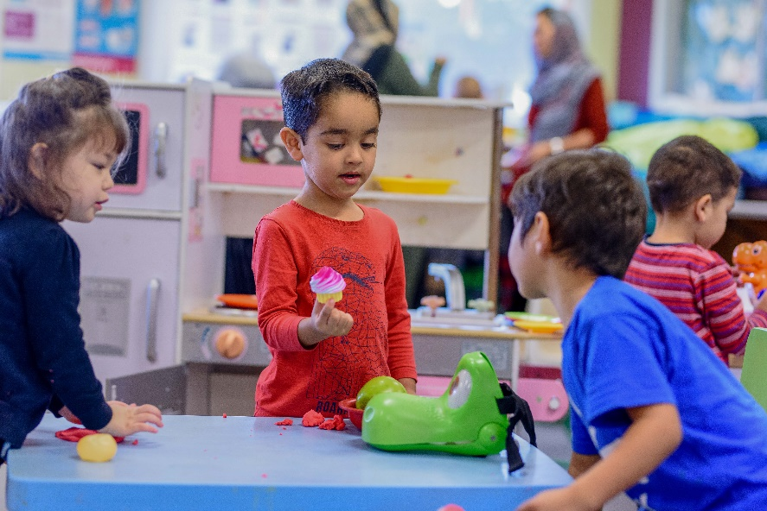

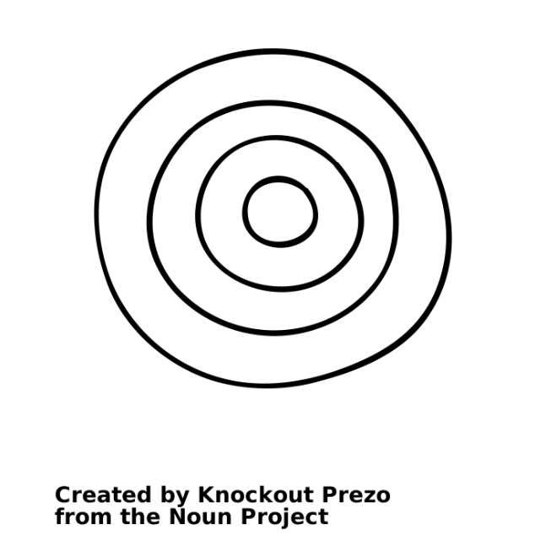

Family-centred and community-focused

The levels of progression in the table below (emerging, evolving, established and excelling) are designed to help you reflect on what you are doing well, and where you might improve. Following this table is a checklist that will assist your reflection and self-assessment.

DOMAIN: Approach

ELEMENT: | 1 – Emerging | 2 – Evolving | 3 – Established | 4 - Excelling
Family-centred and community-focused | The Early Years Place provides child-led play activities that encourage parent participation.  Staff are aware of the importance of family-centred practice.  Early Years Place staff are familiar with the cultural identities of the local community. | Some staff have undertaken training in family-centred practice.  The Early Years Place provides opportunities for families to meet, learn and connect with other families. | The Early Years Place staff and service partners go beyond formal structures/prescribed guidelines to respond to families’ needs (e.g. longer or additional appointments, flexible and fast referral processes).  All staff have received training in family-centred practice.  The Early Years Place intentionally plans and facilitates an environment and range of activities and programs that strengthen supportive, positive connections and social networks between families and other community members. | There is clear evidence of family-centred practice underpinning family support (e.g. use of the Family Partnership Model or equivalent).  Families’ insights, energy and contributions are used to create and improve Early Years Place resources.  Families feel a strong sense of belonging and/or community identity at the Early Years Place.
Consider the examples in the table below and assess whether these form part of your Early Years Place practice.
Excelling
Established
Evolving
Emerging
 | Never | Sometimes | Always | N/A
Early Years Place provides child-led play activities that encourage parent participation.

Staff are aware of the importance of family-centred practice.

Early Years Place staff are familiar with the cultural identities of the local community.

Some staff have undertaken training in family-centred practice.

Early Years Place provides opportunities for families to meet, learn and connect with other families.

Early Years Place staff and service partners go beyond formal structures/ prescribed guidelines to respond to families’ needs (e.g. longer or additional appointments, fast and flexible referral processes).

All staff have received training in family-centred practice.

Early Years Place intentionally plans and facilitates an environment and range of activities and programs that strengthen supportive, positive connections and social networks between families and other community members.
There is clear evidence of family-centred practice underpinning family support (e.g. use of the Family Partnership Model or equivalent).

Families’ insights, energy and contributions are used to create and improve Early Years Place resources.

Families feel a strong sense of belonging and/or community identity at the Early Years Place.

Are there other examples of how your Early Years Place demonstrates a family-centred and community-focused approach that you would like to note?
Response
Click here to enter text.
Are there any challenges or barriers in relation to taking a family-centred and community-focused approach that you would like to note?
Response
Click here to enter text.
Is there anything you would like to do more of or differently to improve how family-centred and community-focused your approach is?
Consider the following reflection questions:
- How well do you understand the challenges and day to day priorities of families you work with?
      - How do families’ priorities align with the priorities of your Early Years Place? If they are different – why?
      - How can families shape your Early Years Places processes, programs or environments?
      - What would a family-centred approach look like for your community?
      - Are families able to decide how and when they will participate at the Early Years Place?
      - Do you have the right people with the right knowledge/skills/values to develop a relationship with the family/community members you are working with?
      - Do you know which community or population groups are not involved with your Early Years Place – and why? What barriers might they be facing?
      - Have you asked families whether they think your approach is family-centred and community-focused? What did they say?
      - How do other Early Years Places take a family-centred and community-focused approach and might this also work for you?
Response
Click here to enter text.

Co-design
The levels of progression in the table below (emerging, evolving, established and excelling) are designed to help you reflect on what you are doing well, and where you might improve. Following this table is a checklist that will assist your reflection and self-assessment.
DOMAIN: Approach
DOMAIN: Approach

ELEMENT: | 1 – Emerging | 2 – Evolving | 3 – Established | 4 - Excelling
Co-design | Families are encouraged to provide feedback about the Early Years Place programs, location of service delivery, design and vision.  Aboriginal and/or Torres Strait Islander and culturally and linguistically diverse families are encouraged to provide feedback about Early Years Place programs and services. | The Early Years Place has processes or tools in place to collect feedback from families (e.g. anecdotal feedback, parent surveys).  Aboriginal and/or Torres Strait Islander and culturally and linguistically diverse families have opportunities to advise on what they need at the Early Years Place.  Families contribute to the vision for the Early Years Place. | Feedback from families is used to inform improvement planning for programs, services and the overall direction of the Early Years Place.  There is a shared understanding of the Early Years Place vision between families, Early Years Place staff and partner agencies.  Families are included as co-producers of services or programs at the Early Years Place. | Families are included in formal Early Years Place governance processes, such as policy development and staff recruitment.  Families regularly act as co-reviewers and/or co-evaluators in Early Years Place improvement planning activities.  Families are informed about how their feedback has been used.  Aboriginal and/or Torres Strait Islander and culturally and linguistically diverse families are co-reviewers and co-evaluators of the Early Years Place, and they have a key role in the improvement planning cycle.

Consider the examples in the table below and assess whether these form part of your Early Years Place practice.
Established
Emerging
Evolving
 | Never | Sometimes | Always | N/A
Families are encouraged to provide feedback about the Early Years Place location, design and vision.
Families are encouraged to provide feedback about the Early Years Place location, design and vision.
Aboriginal and/or Torres Strait Islander and culturally and linguistically diverse families are encouraged to provide feedback about Early Years Place programs and services.
Early Years Place has processes or tools in place to collect feedback from families (e.g. anecdotal feedback, parent surveys).
Aboriginal and/or Torres Strait Islander and culturally and linguistically diverse families have opportunities to advise on what they need at the Early Years Place.
Families contribute to the vision for the Early Years Place.
Feedback from families is used to inform improvement planning for programs, services and the overall direction of the Early Years Place.
There is a shared understanding of the Early Years Place vision between families, staff and partner agencies.
Families are included as co-producers of services or programs at the Early Years Place.
Families are included in formal Early Years Place governance processes, such as policy development and staff recruitment.
Families regularly act as co-reviewers and/or co-evaluators in Early Years Place improvement planning activities.
Aboriginal and/or Torres Strait Islander and culturally and linguistically diverse families are co-reviewers and co-evaluators of the Early Years Place, and they have a key role in the improvement planning cycle.
Families are informed about how their feedback has been used.
Excelling

Are there other examples of how your Early Years Place uses a co-design approach that you would like to note?
Response
Click here to enter text.

Are there any challenges or barriers in relation to adopting co-design practices that you would like to note?
Response
Click here to enter text.
Is there anything you would like to do more of or differently to improve how your Early Years Place uses a co-design
approach with families and community?
Consider the following reflection questions:
- Have you considered how you can include family/community in decision-making processes?
- Have you thought about how the contribution of families/the community to your Early Years Place can be acknowledged?
- How would a parent or member of the community share an idea with you? How would they know what happened with that idea?
- How do other Early Years Places use co-design in the development and delivery of programs and services?
Response
Click here to enter text.

Evidence-based
The levels of progression in the table below (emerging, evolving, established and excelling) are designed to help you reflect on what you are doing well, and where you might like to improve. Following this table is a checklist that will assist your reflection and self-assessment.

DOMAIN: Approach

ELEMENT: | 1 – Emerging | 2 – Evolving | 3 – Established | 4 - Excelling
Evidence-based | The Early Years Place leader uses evidence to support planning and improvement. | Staff are familiar with the evidence and research for effective Early Years Places and use it to support planning and improvement. | Staff are up to date with the latest evidence and research for the services and programs relevant to them.  Staff understand the distinction between evidence-based practice and practice-based evidence and use both in their practice as appropriate. #  Some staff understand how to assess the evidence for programs and services to be implemented at the Early Years Place. | All staff understand how to determine the strength of the evidence for tools, resources and programs implemented at the Early Years Place.  Staff seek out opportunities to further their understanding of the evidence relating to their practice.  The Early Years Place consistently uses data to inform planning and to measure outcomes of programs/services.  Data is used to assess the strength of practice-based evidence.  Early Years Place programs are underpinned by program logics, practice frameworks and guides.
Consider the examples in the table below and assess whether these form part of your Early Years Place practice.
Established
Evolving
Emerging
Excelling
 | Never | Sometimes | Always | N/A
The Early Years Place leader uses evidence to support planning and improvement

All staff are familiar with the evidence for Integrated Early Years Places and use it to support planning and improvement.

Staff are up to date with the latest evidence for the services and programs relevant to them.

Staff are up to date with the latest evidence for the services and programs relevant to them.
Staff understand the distinction between evidence-based practice and practice- based evidence and use both in their practice as appropriate.
Some staff understand how to assess the evidence for programs/services to be implemented at the Early Years Place.
All staff understand how to determine the strength of the evidence used to develop tools, resources and programs implemented at the Early Years Place.
Staff seek out opportunities to further their understanding of the evidence relating to their practice.
The Early Years Place consistently uses data to inform planning and to measure outcomes of programs/services.
Data is used to assess the strength of practice-based evidence (understanding and measuring the outcomes produced from the activities implemented).
Early Years Place programs are underpinned by program logics, practice frameworks and guides.

Are there other examples of how your Early Years Place takes an evidence-based approach that you would like to note?
Response
Click here to enter text.
Are there any challenges or barriers in relation to taking an evidence-based approach that you would like to note?
Response
Click here to enter text.
Is there anything you would like to do more of or differently to improve use of evidence within your Early Years Place?
Consider the following reflection questions:
    - How do you stay up to date with the latest research and evidence for your development and implementation of your Early Years Place’s services and programs?
    - How do you ensure your services and programs are evidence-based?
    - How are you collecting practice-based evidence? What monitoring and learning systems do you have in place?
    - Are you sharing what works for you with other Early Years Places?
    - Are other Early Years Places using any evidence-based tools or programs that might be suitable for your Early Years Place?
Response
Click here to enter text.

Self-assessment and reflection complete

Well done! You have completed your self-assessment and reflection of the Approach domain. We hope this has helped to pinpoint areas of focus for future planning and improvement.

Remember to save a copy of your responses for your records.

