Engagement
Effective Early Years Places seek to engage all families, particularly those facing multiple challenges or marginalisation. Successful engagement requires Early Years Places to take on the responsibility of ‘finding’ disengaged families, then delivering services, programs and support in ways that feel inclusive, and that facilitate positive family change and growth.
Within the 'Engagement' domain, you will be asked to assess and reflect on three key elements:
    - Reaching out
    - Inclusion
    - Training and employment pathways for families
The following pages will help guide your assessment and reflection, as you consider how well your Early Years Place engages with children and families in your community.
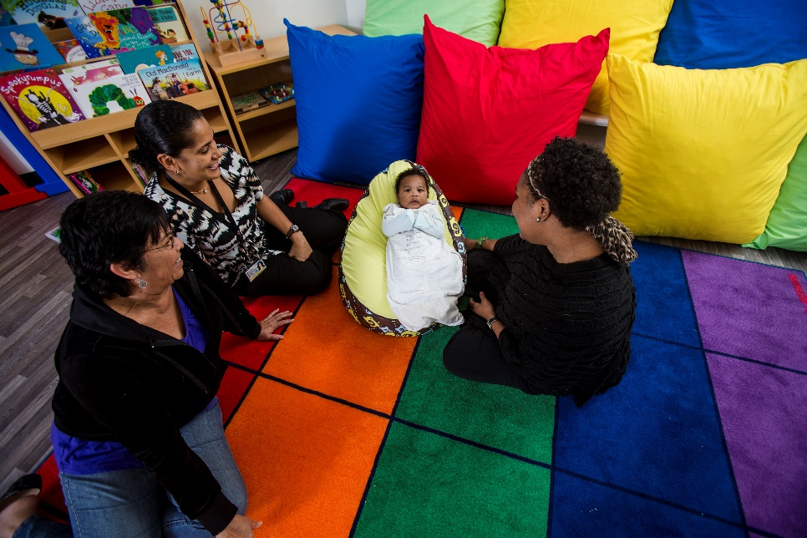
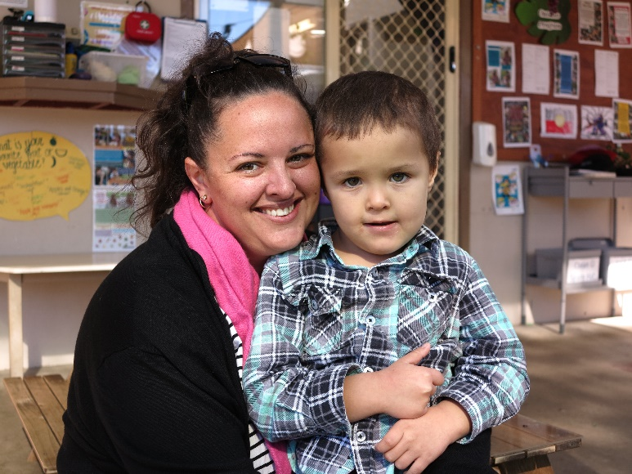

Reaching out
The levels of progression in the table below (emerging, evolving, established and excelling) are designed to help you reflect on what you are doing well, and where you might like to improve. Following this table is a checklist that will assist your reflection and self-assessment.

DOMAIN: Engagement
ELEMENT: | 1 – Emerging | 2 – Evolving | 3 – Established | 4 - Excelling
Reaching out | Early Years Place staff are learning about and building understanding of the needs of highly vulnerable families in their community. | The Early Years Place has developed clear, documented policies and procedures for reaching out/outreach activities, including safety practices and risk assessments.  Early Years Place staff test strategies to identify, engage and/or respond to the needs of highly vulnerable families. | The Early Years Place uses a number of strategies to find and build relationships with families who are isolated, marginalised or not connected with services.  The Early Years Place has developed evidence for some promising strategies to identify and engage with highly vulnerable families in the community.  The Early Years Place connects early with new and expectant parents to promote services/programs.  Other community places/ spaces used by families with young children actively promote the Early Years Place.  Early Years Place uses technology where appropriate and possible to reach out to families to assist in keeping attending families engaged. | The Early Years Place identifies and actively engages under-represented groups, including young parents, dads, Aboriginal and Torres Strait Islander and culturally and linguistically diverse families.  Trained community volunteers work alongside Early Years Place staff or practitioners to reach out to marginalised families.  Early Years Place staff can co-visit families in the home and/or other neutral spaces with other practitioners and early childhood educators.  Staff understand, document, regularly review and actively address the reasons why families do not engage or have stopped engaging with the Early Years Place.  Staff encourage families attending the Early Years Place to connect with and invite new parents and parents/carers not attending to visit the Early Years Place.  The Early Years Place makes phone or in-person wellbeing checks on families that have not attended for a period of time.

Consider the examples in the table below and assess whether these form part of your Early Years Place practice.
Never
Evolving
Emerging

Established
 | Never | Sometimes | Always | N/A
Early Years Place staff are developing an understanding of the needs of highly vulnerable families in their community.
The Early Years Place has developed clear, documented policies and procedures for reaching out/outreach activities, including safety practices and risk assessments.
Early Years Place staff develop and test strategies to identify, engage and/or respond to the needs of highly vulnerable families.
The Early Years Place uses a number of strategies to find and build relationships with families who are isolated, marginalised or not connected with services. The Early Years Place does rely solely on families attending centre-based activities.
The Early Years Place has developed evidence for some promising strategies to identify and engage with highly vulnerable families in the community.
The Early Years Place connects early with new and expectant parents/carers to promote services/programs.
Other community places/spaces used by families with young children actively promote the Early Years Place.
The Early Years Place uses technology where appropriate and possible to reach out to new families and to help keep attending families engaged.
Early Years Place identifies and actively engages underrepresented groups, including young parents, dads, Aboriginal and Torres Strait Islander and culturally and linguistically diverse families.
Trained community volunteers work alongside Early Years Place staff or practitioners to deliver outreach programs and activities.
The Early Years Place staff can co-visit families in the home and/or other neutral spaces with practitioners including health staff.
Staff work with families and community leaders to understand, document, regularly review and actively address the reasons they do not engage or have stopped engaging with the Early Years Place.
Staff encourage families attending the Early Years Place to connect with and invite new parents/carers not attending to visit the Early Years Place.
Early Years Place makes phone or in-person wellbeing checks on families that have not attended for a period of time.
Excelling

Are there other examples of reaching out strategies you use with your community that you would like to note?

Response
Click here to enter text.

Are there any challenges or barriers in relation to reaching out to families (including home visiting or engaging with families in a variety of settings) that you would like to note?

Is there anything you would like to do more of or differently to improve your ability to reach out to families in your community?
Consider the following reflection questions:
- Do you know which families or community or population groups are not attending your Early Years Place? What specific activities could you do to engage them?
- What do you know about families that have only attended your Early Years Place once or twice? What are you doing in response?
- Do you ask currently attending families to reach out to other families in the community?
- How do you know your reaching out strategies are working?
- What strategies have other Early Years Places tried that might also work for you?

Response
Click here to enter text.

Inclusion
The levels of progression in the table below (emerging, evolving, established and excelling) are designed to help you reflect on what you are doing well, and where you might like to improve. Following this table is a checklist that will assist your reflection and self-assessment.
DOMAIN: Engagement

DOMAIN: Engagement

ELEMENT: | 1 – Emerging | 2 – Evolving | 3 – Established | 4 - Excelling
Inclusion | Plans are in place for Early Years Place staff to receive training in inclusive practices.  The Early Years Place is connecting with Aboriginal and Torres Strait Islander and culturally and linguistically diverse families and developing relationships. | Early Years Place staff are trained in inclusive practices. Language used in the Early Years Place is inclusive of all families.  Staff are trained in physical and mental health first aid and are friendly and non-judgemental.  Staff value diversity and organise special events to celebrate important dates in the local communities’ calendars. | Early Years Place staff are trained in inclusive practices and are supported to apply them in their work.  Staff have trusted relationships and working partnerships with Aboriginal and Torres Strait Islander and culturally and linguistically diverse communities and other Aboriginal and Torres Strait Islander and culturally and linguistically diverse support agencies.  Staff have undertaken cultural safety training. | Families feel welcome, safe, accepted, supported, valued and understood.  Staff consistently survey families to ensure programs, processes and procedures are culturally safe, and act on the results.  Families who have not previously engaged well with programs/services keep attending the Early Years Place over time.  Local community leaders/elders are visible at the Early Years Place.  Families can attend the Early Years Place at any time during opening hours.  Opening hours respond to local families’ needs as far as possible.
Continued over page...

ELEMENT: | 1 – Emerging | 2 – Evolving | 3 – Established | 4 - Excelling
Inclusion | The Early Years Place visually celebrates Aboriginal and Torres Strait Islander and culturally and linguistically diverse families' cultures. | Programs and events are offered to engage specific groups of families, e.g. dads, grandparents, carers.  The program schedule is available in different languages, and is available in printed format and online.  Children feel safe, calm and comfortable at the Early Years Place. | The Early Years Place uses evidence-based strategies to identify and engage with people living in vulnerable circumstances in the communities. Families set the pace for interaction, taking gradual steps if necessary.  Parents/carers are trained as co-workers to create a safer and more comfortable environment for new families.  Families feel welcome, safe, heard, respected, and able to make their own choices.  The Early Years Place provides programs/events that enable families to engage with their culture. | Supervision is provided for children if needed, for example through adjunct care.  Early Years Place staff are trained in trauma-informed practices and are vigilant in reviewing spaces and programs for anything that may trigger a trauma response.  Families do not feel any stigma or judgement associated with attending the Early Years Place spaces.

Consider the examples in the table below and assess whether these form part of your Early Years Place practice.

A
Emerging
 | Never | Sometimes | Always | N/A
Early Years Place staff are developing an understanding of the needs of highly vulnerable families in their community.

Evolving
Established
 | Never | Sometimes | Always | N/A
Plans are in place for Early Years Place staff to receive training in inclusive practices, i.e. they have not yet attended training.
The Early Years Place is connecting with Aboriginal and Torres Strait Islander and culturally and linguistically diverse families and developing relationships.
The Early Years Place visually celebrates Aboriginal and Torres Strait Islander and culturally and linguistically diverse families' cultures.
Early Years Place staff are trained in inclusive practices. Within the centre/other locations language is important and is inclusive of all families.
Staff are trained in physical and mental health first aid and are friendly and non-judgmental.
Staff value diversity and organise special events to celebrate important dates on the local communities’ calendars.
Programs and events are offered to engage specific groups of families, e.g. dads, grandparents, carers.
Program schedule is available in languages reflective of the local community, and is available in printed format and online.
Children feel safe, calm and comfortable at our Early Years Place.

Staff have trusted relationships and working partnerships with Aboriginal and Torres Strait Islander and culturally and linguistically diverse communities and other Aboriginal and Torres Strait Islander and culturally and linguistically diverse support agencies
Early Years Place staff are trained in inclusive practices and are supported to apply them

Early Years Place staff have undertaken cultural safety training

Continued over page...
Sometimes
ways

Established
Excelling
 | Never | Sometimes | Always | N/A
Parents/caregivers are trained as co-workers to create a safer and more comfortable environment for new families.
Families feel welcome, safe, heard, respected, and able to make their own choices.
The Early Years Place provides programs/events that enable families to engage with their culture.
The Early Years Place uses research and evidence-based strategies to identify and engage with people living in vulnerable circumstances. Families set the pace for interaction, with staff focusing on building trust to build engagement over time.
Families feel welcome, safe, accepted, supported, valued and understood.
Staff consistently survey families to ensure programs, processes and procedures are culturally safe, and act on the results.
Families who have not previously engaged well with services keep attending our Early Years Place over time.
Local community leaders/elders are visible at the Early Years Place.
Families can attend our Early Years Place at any time during opening hours.
Opening hours respond to local families’ needs.
Supervision is provided for children if needed.

Early Years Place staff are trained in trauma-informed practices and are vigilant in reviewing spaces and programs for anything that may trigger a trauma response.

Families do not feel any stigma or judgement associated with attending our Early Years Place spaces

.

Are there other examples of inclusion from your Early Years Place that you would like to note?

Response
Click here to enter text.

Are there any challenges or barriers in relation to inclusion that you would like to note?

Response
Click here to enter text.

Is there anything you would like to do more of or differently to improve inclusion for families in your community?
Consider the following reflection questions:
- How would a parent/carer describe their relationship with the Early Years Place or with the services provided?
- How might you encourage families to feel ownership of the space?
- Are children genuinely welcome to be part of what you are doing – are they valued and encouraged to belong?
- How deeply do you understand the cultural context of the people you are working with?
- How could you host families in a way that values and empowers them and removes barriers to participation?
- How might you seek to establish meaningful relationships in culturally appropriate ways?
- What have other Early Years Places done to improve inclusion that might also work for you?

Response
Click here to enter text.

Training and employment pathways
The levels of progression in the table below (emerging, evolving, established and excelling) are designed to help you reflect on what you are doing well, and where you might like to improve. Following this table is a checklist that will assist your reflection and self-assessment.
DOMAIN: Engagement

ELEMENT: | 1 – Emerging | 2 – Evolving | 3 – Established | 4 - Excelling
Training and employment pathways | Parents/carers feel confident to support and learn from each other. | Parents/carers are beginning to take responsibility for providing informal support to other parents/carers.  The Early Years Place plans for and offers adult learning opportunities.  Families or community members are beginning to be trained and/or supported in informal or formal roles at the Early Years Place. | Parents/carers have the skills, knowledge and confidence to support and learn from each other, including through trained volunteer and paid employment opportunities at our Early Years Place.  Parents/carers are supported to access other courses that will help employment prospects.  Families and community members receive the required support and/or training for informal or formal roles at our Early Years Place. | The Early Years Place provides a range of safe and supportive adult learning opportunities, including informal and formal training and learning.  The Early Years Place pays attention to and addresses dynamics affecting learning, including issues regarding literacy and numeracy.  Families and community members are regular and reliable volunteers and/or employed at the Early Years Place.  Staff continuity planning actively considers employment opportunities for families/community members.  Families are supported, where possible, to access local training courses, including TAFE and University.  The Early Years Place partners with organisations to provide clear learning pathways to a range of qualifications, including accreditation, certificate (e.g. first aid) and qualifications (e.g. certificate 3, diploma).

Consider the examples in the table below and assess whether these form part of your Early Years Place practice.
Emerging
Evolving
Excelling
Established
Excelling
Established
Evolving
 | Never | Sometimes | Always | N/A
Parents feel confident to support and learn from each other.

Parents are beginning to take responsibility for providing informal support to other parents.
The Early Years Place plans for and offers adult learning opportunities, with partner agencies.

Families or community members are beginning to be trained and/or supported in informal or formal roles at our Early Years Place.
Parents have the skills, knowledge and confidence to support and learn from each other, including through trained volunteer and employment opportunities at our Early Years Place.
Parents are supported to access courses that will help employment prospects.
Families and community members receive the required support and/or training for informal or formal roles at the Early Years Place.
The Early Years Place provides a range of safe and supportive adult learning opportunities, including informal and formal training and learning.
The Early Years Place pays attention to and addresses dynamics affecting learning, including issues regarding literacy, numeracy, etc.
Families and community members are regular and reliable volunteers and/or employed at the Early Years Place.
Ongoing staff continuity planning actively considers employment opportunities for appropriately
qualified families/community members.
The Early Years Place partners with various organisations, including TAFE and Universities to provide clear learning pathways to a range of qualifications, including accreditation, certificate (e.g. first aid) and qualifications (e.g. certificate 3, diploma).
Are there other examples of training or employment pathways you offer families through your Early Years Place that you would like to note?
Response
Click here to enter text.

Are there any challenges or barriers in relation to creating training or employment pathways, with partner agencies that you would like to note?
Response
Click here to enter text.

Is there anything you would like to do more of or differently to improve training or employment pathways for families in your community?
Consider the following reflection questions:
- How could your Early Years Place support peer-to-peer learning (e.g. parents learning from other parents)?
- What volunteer or paid positions could be made available at your Early Years Place for caregivers to take up?
- How might you use your space to facilitate adult learning opportunities, with partner agencies?
- What training or employment opportunities are other Early Years Places creating?
Response
Click here to enter text.

Self-assessment and reflection complete

Well done! You have completed your self-assessment and reflection of the Engagement domain. We hope this has helped to pinpoint areas of focus for future planning and improvement.

Remember to save a copy of your responses for your records.

