Management, leadership and quality improvement
Effective Early Years Places will have strong leadership and governance structures, with governance ideally including families and community members. A commitment to continuous quality improvement in planning cycles helps to drive better outcomes for families.

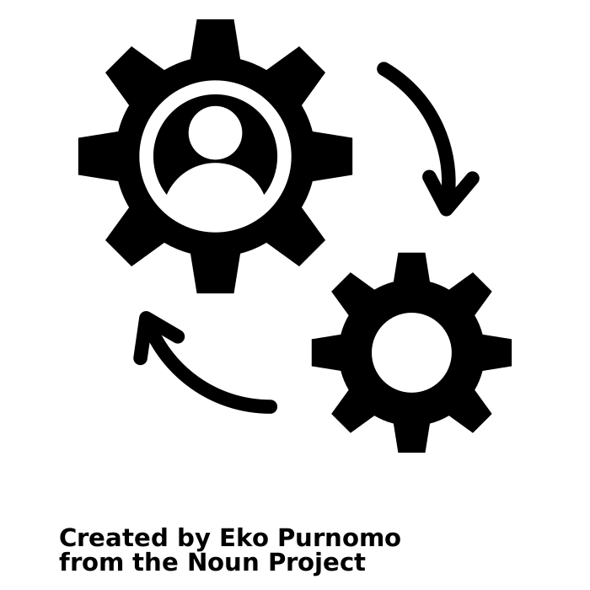
Within the 'Management, leadership and quality improvement' domain, you will be asked to assess and reflect on two key elements:

- Management, leadership and governance
- Quality and improvement
The following pages will help guide your assessment and reflection, as you consider how well your management, leadership and governance structures enable your Early Years Place to achieve its goals for children and families.

Management, leadership and governance

The levels of progression in the table below (emerging, evolving, established and excelling) are designed to help you reflect on what you are doing well, and where you might improve. Following this table is a checklist that will assist your reflection and self-assessment.
DOMAIN: Management, leadership and quality improvement

ELEMENT: | 1 – Emerging | 2 – Evolving | 3 – Established | 4 - Excelling
Management, leadership and governance | The Early Years Place understands the required staff resources to undertake core activities and meet targeted community needs.  Staff induction covers principles of integrated service delivery and working with marginalised families. | There are adequate staff resources to scope and undertake core Early Years Place activities to meet targeted community needs.  Early Years Place staff are able to access an employee assistance program.  Early Years Place staff have time to build relationships with other stakeholders. | There is minimal Early Years Place staff turnover, enabling continuity of service delivery.  Early Years Place staff are able to quickly access counselling and psychological support as required.  All Early Years Place staff plus co-located and visiting practitioners and services have a good understanding of each other’s roles. | Continuity planning for all Early Years Place roles is regularly undertaken and monitored to support continuity of service delivery.  Joint sustainable funding is used to deliver on agreed Early Years Place outcomes and activities over multiple years (if required).  Policies and procedures are reviewed and updated on a regular basis.
Continued over page...

ELEMENT: | 1 – Emerging | 2 – Evolving | 3 – Established | 4 - Excelling
Management, leadership and governance | Early Years Place has wellbeing support in place for staff.  Early Years Place has built or is building relationships with a small number of services. | The Early Years Place leader has a good understanding of all Early Years Place staff roles, including Aboriginal and Torres Strait Islander Early Years Education Workers and Aboriginal Family Worker roles, where appropriate.  Time and budget are allocated for reflection and staff professional development.  Active networking between Early Years Place staff and service partners is encouraged. | All Early Years Place staff feel connected to their Early Years Place peers and have the opportunity to participate in a network with their Early Years Place peers.  Some pooled funding is available through a shared funding arrangement with service partners, where appropriate.  Early Years Place staff and service partners share a common language, may offer feedback to each other, and attend joint professional development activities.  Funding is appropriate to ensure continuity of services and supports. | Policies provide a clear support structure and procedures to promote and maintain staff wellbeing and manage staff trauma, anxiety, stress and burn out (e.g. regular group support is undertaken by Early Years Place teams).  Families, Early Years Place staff and all practitioners have a good understanding of each other’s roles and are able to clearly communicate these to others.  Early Years Place culture values reflection and improvement and staff and service users feel safe to speak up.  Integration with service partners - including coordinated planning - enables the Early Years Place to be nimble and flexible with service/program offerings in response to local needs.

Sometimes

Consider the examples in the table below and assess whether these form part of your Early Years Place practice.
Established
Emerging
Evolving
 | Never | Sometimes | Always | N/A
The Early Years Place understands the required staff resources needed to undertake core activities and meet targeted community needs.
Staff induction covers principles of integrated service delivery and working with marginalised families.
The Early Years Place has wellbeing support in place for staff.

There are adequate staff resources to scope and undertake core Early Years Place activities to meet targeted community needs.
Early Years Place staff are able to access an employee assistance program.
Time and budget are allocated for reflection and staff professional development.
The Early Years Place leader has a good understanding of all Early Years Place staff roles, including Aboriginal and Torres Strait Early Years Education Worker and Aboriginal Family Worker roles, where appropriate.
Active networking between Early Years Place staff and service partners is encouraged.

There is minimal Early Years Place staff turnover, enabling continuity of service delivery.

Early Years Place staff are able to quickly access counselling and professional support, as required.

All Early Years Place staff plus co-located and visiting practitioners have a good understanding of each other’s roles.

Continued over page...
Excelling

 | Never | Sometimes | Always | N/A
Some pooled funding is available through a shared funding arrangement with service partners, where appropriate.
Established
All Early Years Place staff feel connected to their Early Years Place peers and have the opportunity to participate in a network with their Early Years Place peers.

Early Years Place staff and service partners share a common language, may offer feedback to each other, and attend joint professional development activities.

Funding supports continuity of services and supports.

Continuity planning for all Early Years Place roles is regularly undertaken and monitored to support continuity of service delivery

Joint sustainable funding is used to deliver on agreed Early Years Place outcomes and activities over multiple years (if required).

Policies and procedures are reviewed and updated on a regular basis.
Excelling
Policies provide a clear support structure and procedures to promote and maintain staff wellbeing and manage staff trauma, anxiety, stress and burn out (e.g. regular group professional support is undertaken by Early Years Place teams).
Families, Early Years Place staff and all practitioners have a good understanding of each other’s roles and are able to clearly communicate these to others.
Early Years Place culture values reflection and improvement and staff and service users feel safe to speak up.
Integration with service partners - including coordinated planning - enables the Early Years Place to be nimble and flexible with service/program offerings in response to local needs.

Are there other examples of good management, leadership or governance at your Early Years Place that you would like to note?
Are there any challenges or barriers in relation to management, leadership or governance that you would like to note?
Response
Click here to enter text.

Is there anything you would like to do more of or differently to improve your Early Years Place management, leadership or governance?
Consider the following reflection questions:
- Where does your Early Years Place sit within the ecosystem of services available to families in your local community? What relationships do you have with other services, and are you prepared to share power and control to achieve positive change?
- In what ways are leaders enabling staff and practitioners to work in flexible and responsive ways? What might be getting in the way?
- What strategies are put in place to ensure that all practitioners and services working within the Early Years Place (including from partner agencies) function as a team?
- How are you involving families in governance and decision-making?
- What do families think about the way your Early Years Place is led and managed?
- What insights could you gather from other Early Years Places that might be helpful for you?
Response
Click here to enter text.

Quality improvement

The levels of progression in the table below (emerging, evolving, established and excelling) are designed to help you reflect on what you are doing well, and where you might improve. Following this table is a checklist that will assist your reflection and self-assessment.
DOMAIN: Management, leadership and quality improvement
DOMAIN: Management, leadership and quality improvement

ELEMENT: | 1 – Emerging | 2 – Evolving | 3 – Established | 4 - Excelling
Quality improvement | Review and quality assurance processes are in place for each service/ agency.  Early Years Place quality is assessed annually by/with staff.  Our Early Years Place identifies areas for new inquiry/ exploration. | Services/programs have separate reporting processes but contribute to Early Years Place annual reviews and improvement planning.  Our Early Years Place leader has built a shared understanding of how to apply an improvement cycle within our context.  Family feedback is used as part of the review and improvement planning process. | There is one review and reporting process for services/programs involved with the Early Years Place.  Early Years Place staff collaborate to jointly understand and implement the improvement cycle within the Early Years Place context.  Families are active participants in the review and improvement planning process.  The Early Years Place has rapid access to existing data sets from multiple relevant and reliable sources. | Key actions within the Early Years Place Improvement Plan reflect an ongoing collaborative inquiry approach.  Families are trained and supported as co-reviewers / co-evaluators as part of the review and improvement planning process.  Early Years Place staff improvise and innovate to respond to emerging needs (e.g. finding new ways to celebrate diversity).  The Early Years Place has real-time access to existing data sets from multiple relevant and reliable sources.

Continued over page...

ELEMENT: | 1 – Emerging | 2 – Evolving | 3 – Established | 4 - Excelling
Quality improvement |  | The Early Years Place undertakes some occasional inquiries/investigation about new or specific problems and opportunities.  Early Years Place quality is assessed with Early Years Place staff, with a focus on reflection, learning and improvement (not performance management).  Staff understand the importance of learning, monitoring, evaluation and improvement. | The Early Years Place integrates ongoing learning and investigation about problems or opportunities into improvement planning – they do not assume challenges are stable and known.  Early Years Place quality is assessed using multiple forms of evidence (e.g. lived experience of families, lived experience of Early Years Place staff, service partners and data) and drives learning and improvement planning throughout the year.  The Early Years Place data collection plan generates meaningful, credible and relevant data, which is integrated into ongoing learning, reflection and improvement.  Early Years Place staff capacity in learning, monitoring, evaluation and improvement is built through ongoing professional learning. | All Early Years Place staff understand what data is being collected and why, and confidently contribute to team discussions to make sense of the data and to identify next steps.  The Early Years Place has developed a research partnership with academic or other institutions to support learning about Early Years Place progress and impact, and to build Early Years Place staff capacity in learning, monitoring, evaluation and improvement.

Consider the examples in the table below and assess whether these form part of your Early Years Place practice.
Excelling
Emerging
Evolving
Established
Evolving
 | Never | Sometimes | Always | N/A
Review and quality assurance processes are in place for each service/agency.

Early Years Place quality is assessed annually with/by staff.

Our Early Years Place identifies areas for new inquiry/exploration.
Services/programs have separate reporting processes but contribute to Early Years Place annual reviews and improvement planning.

Our Early Years Place leader has built a shared understanding of how to apply an improvement cycle within our context.

Family feedback is used as part of the review and improvement planning process.

The Early Years Place undertakes some occasional inquiries/investigation into new or specific problems or opportunities.
.
The Early Years Place quality is assessed with Early Years Place staff, with a focus on reflection, learning and improvement (not performance management).

Staff understand the importance of learning, monitoring, evaluation and improvement.

There is one review and reporting process for services/programs involved with the Early Years Place.

Early Years Place staff collaborate to jointly understand and implement the improvement cycle within the Early Years Place context.

Families are active participants in the review and improvement planning process.

Continued over page...
Excelling
Excelling
Never Sometimes Always N/A
 | Never | Sometimes | Always | N/A
The Early Years Place has rapid access to existing data sets across a range of sources.
The Early Years Place integrates ongoing learning about problems or opportunities into improvement planning – they do not assume challenges are stable and known.
Early Years Place quality is assessed using multiple forms of evidence (e.g. lived experience of families, lived experience of Early Years Place staff and service partners, data) and drives learning and improvement planning throughout the year.
Early Years Place data collection plan generates meaningful, credible and relevant data, which is integrated into ongoing learning, reflection and improvement.
Early Years Place staff capacity in learning, monitoring, evaluation and improvement is built through ongoing professional learning.
Key actions within the Early Years Place Improvement Plan reflect an ongoing collaborative inquiry approach.
Families are trained and supported as co-reviewers / co-evaluators as part of the review and improvement planning process.
Early Years Place staff improvise and innovate to respond to emerging needs (e.g. finding new ways to celebrate diversity)
The Early Years Place has real-time access to existing data sets from relevant and reliable sources.
All Early Years Place staff understand what data is being collected and why, and confidently contribute to team discussions to make sense of the data and identify next steps.
The Early Years Place has developed a research partnership with academic or other institutions to support learning about Early Years Place progress and impact, and to build Early Years Place staff capacity in learning, monitoring, evaluation and improvement.

Are there other examples of how your Early Years Place ensures quality improvement that you would like to note?
Response
Click here to enter text.

Are there any challenges or barriers in relation to quality improvement that you would like to note?
Is there anything you would like to do more of or differently in relation to quality improvement for your Early Years Place?
Consider the following reflection questions:
- Where do you look for new ideas and fresh thinking? Are you seeking out new perspectives and insights that challenge current approaches?
      - How does the learning from your current practice inform your future practice?
      - What policies and systems exist that enable quality standards to be achieved across your Early Years Place?
      - What gaps exist? What could be done about those gaps?
Response
Click here to enter text.

What insights could you gather from other Early Years Places that might be helpful for you?
Response
Click or tap here to enter text.

Self-assessment and reflection complete

Well done! You have completed your self-assessment and reflection of the Management, leadership and quality improvement domain.

We hope this has helped to pinpoint areas of focus for future planning and improvement. Remember to save a copy of your responses for your records.

