Places and environments
Effective Early Years Places feel inclusive, welcoming, and culturally safe for all families. They are ideally established in locations or settings that are accessible for vulnerable families with young children, including families without their own transport and family members with disability.
Within the 'Places and environments' domain, you will be asked to assess and reflect on two key elements:
    - Calm and safe places and environments
    - Accessible places and environments

The following pages will help guide your assessment and reflection, as you consider whether the places and environments used to meet with children and families are contributing to families' sense of welcome, comfort and
safety.

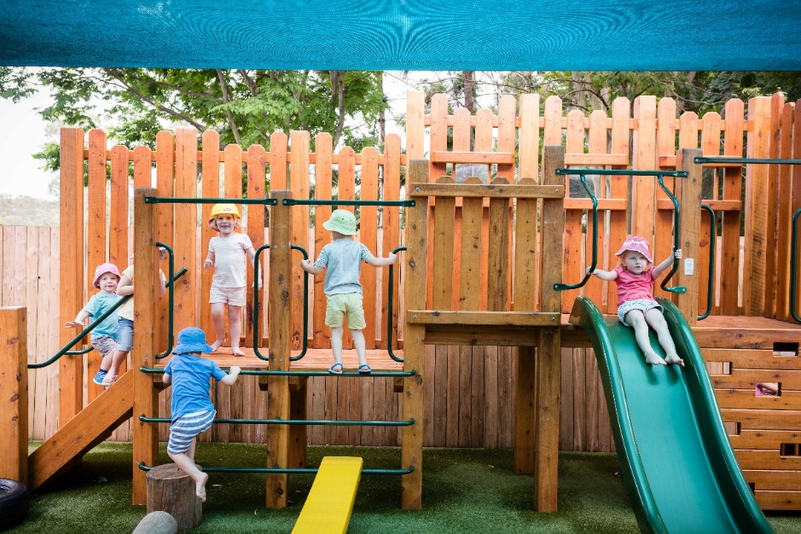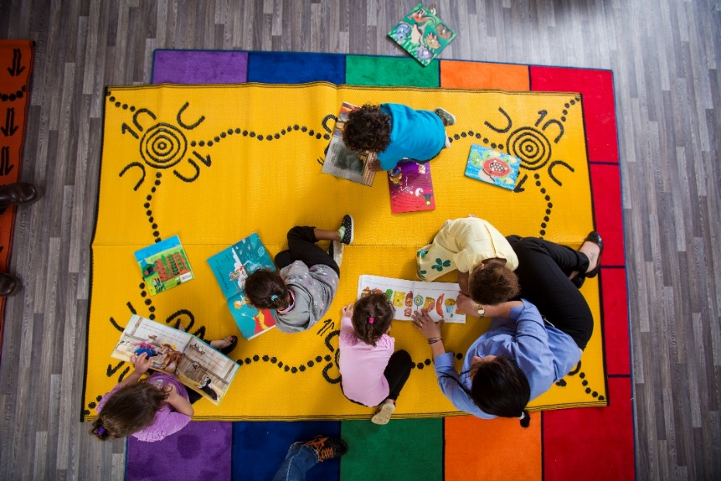

Calm and safe
The levels of progression in the table below (emerging, evolving, established and excelling) are designed to help you reflect on what you are doing well, and where you might like to improve. Following this table is a checklist that will assist your reflection and self-assessment.
DOMAIN: Places and environments
DOMAIN: Places and environments

ELEMENT: | 1 – Emerging | 2 – Evolving | 3 – Established | 4 - Excelling
Calm and safe | We warmly greet and welcome all families that attend our Early Years Place.  Entry into our Early Years Place space is warm and inviting.  Children are welcomed at our Early Years Place. | Families identify the physical environment as welcoming and safe.  Children feel comfortable at our Early Years Place. | Community members perform volunteer roles involving greeting and welcoming visitors.  Early Years Place spaces are designed to allow families to take a break and unwind from everyday stresses. | Families see the Early Years Place space as belonging to them.  Spaces look and feel culturally safe.

Consider the examples in the table below and assess whether these form part of your Early Years Place practice.
Emerging
Excelling
Established
Evolving
 | Never | Sometimes | Always | N/A
We warmly greet and welcome all families that attend our Early Years Place.

Entry into our Early Years Place space is warm and inviting.
Children are welcomed at our Early Years Place.

Families identify the physical environment as welcoming and safe.

Children feel comfortable at our Early Years Place.

Community members perform volunteer roles involving greeting and welcoming visitors.

Early Years Place spaces are designed to allow families to take a break and unwind from everyday stresses.

Families see the Early Years Place space as belonging to them.

Spaces look and feel culturally safe.

Are there other examples of how your Early Years Place creates calm and safe environments that you would like to note?

Response
Click here to enter text.

Are there any challenges or barriers to creating calm and safe environments that you would like to note?

Response
Click here to enter text.

Is there anything you would like to do more of or differently to improve your Early Years Place in relation to being calm and safe?
Consider the following reflection questions:
- How might you create calm spaces that provide a respite for families from the stressors of daily life? Are there any visual or auditory elements in your space that might trigger trauma?
- What small things could you do that might reduce parents’ stress, make their day a bit easier or make them feel cared for?
- How do you make families feel welcome when they visit your space?
- How are your actions improving the cultural safety of the Early Years Place environment for young families? Do you have the right expertise/advice to ensure a culturally appropriate environment?
- Does your staffing model reflect the cultural diversity of your community? How could this be improved?
- In what ways does the Early Years Place environment help or hinder engagement with families?
- Have you asked families what they think about your space? What do they say?
- What have other Early Years Places done to make their spaces calm and safe?
Response
Click here to enter text.

Accessible
The levels of progression in the table below (emerging, evolving, established and excelling) are designed to help you reflect on what you are doing well, and where you might like to improve. Following this table is a checklist that will assist your reflection and self-assessment.
DOMAIN: Places and environments
DOMAIN: Places and environments

ELEMENT: | 1 – Emerging | 2 – Evolving | 3 – Established | 4 - Excelling
Accessible | The Early Years Place facilities or services are located within the local community.  The Early Years Place is easy for families to access.  The Early Years Place provides some accessible play spaces for children.  Entrances to our Early Years Place are clearly signed.  Program schedules are displayed visually. | Play spaces are accessible for all children.  Our Early Years Place is actively promoted to the local community. | Physical spaces are designed to promote safety, openness and connection.  Physical spaces can be used flexibly to respond to community needs.  Our Early Years Place uses technology where appropriate and possible to facilitate accessibility. | Where we meet is directed by the families using our services.  The Early Years Place supports access to transport for those who otherwise would not be able to attend.  Early Years Place provides some out-of-hours services/programs for families who cannot attend during business hours.  Early Years Place delivers bilingual programs.  Early Years Place is accessible to children and parents with disability.  Staff can deliver in-home services where there are barriers to families accessing our Early Years Place.

Consider the examples in the table below and assess whether these form part of your Early Years Place practice.
Emerging
Established
Evolving
 | Never | Sometimes | Always | N/A
Early Years Place facilities or services are located within our local community.
The Early Years Place is easy for families to access.
The Early Years Place provides some accessible play spaces for children.
Entrances to our Early Years Place are clearly signed.

Program schedules are displayed visually.

Play spaces are accessible for all children.

The Early Years Place is actively promoted to the local community.
Physical spaces are designed to promote safety, openness and connection.
Physical spaces can be used flexibly to respond to community needs.

The Early Years Place uses technology where appropriate and possible to facilitate accessibility.

Continued over page...

Neve
Excelling
 | Never | Sometimes | Always | N/A
Where we meet is directed by the families using our services.

The Early Years Place supports access to transport for those who otherwise would not be able to attend.
The Early Years Place provides some out-of-hours services/programs for families who cannot attend during business hours.
The Early Years Place delivers bilingual programs, as appropriate.

The Early Years Place is accessible to children and parents with disability.
Staff can deliver in-home services where there are barriers to families accessing our Early Years Place.

Are there other examples of how your Early Years Place demonstrates accessibility that you would like to note?

Response
Click here to enter text.

Are there any challenges or barriers in relation to accessibility that you would like to note?

Response
Click here to enter text.

Is there anything you would like to do more of or differently to improve the accessibility of your Early Years Place?
Consider the following reflection questions:
- How easy is it for families to access your Early Years Place?
- What strategies could you employ to reach families who struggle to access your Early Years Place?
- What resources could you draw on to encourage more families to access your Early Years Place?
- Have you asked families what they think about how accessible your Early Years Place is? What do they say?
- What have other Early Years Places done to make their services and programs more accessible? Might those ideas also work for you?

Response

Self-assessment and reflection complete

Well done! You have completed your self-assessment and reflection of the Places and Environments domain. We hope this has helped to pinpoint areas of focus for future planning and improvement.

Remember to save a copy of your responses for your records.

