Queensland Kindergarten Funding Scheme

Guide for QGrants

Quarterly Claims – Long Day Care

Contents

Getting Started 3

Accessing QGrants 3

Submitting a Quarterly Claim 3

1 Claim Period 4

2 LDC Details 5

3 Teacher/s Details 7

4 Enrolment Details 8

5 QKFS Plus Details 9

6 Cancellations 10

7 Attachments 11

8 Bank Details 13

9 Declaration 14

10 Summary 15

Transition Statements (Quarter 4 claims only) 16

Additional program claims 17

Viewing previously submitted claims 17

Claim Status - More Information 17

Claim Adjustments 18

Requesting your claim adjustment 18

# Getting Started

Prior to starting a QGrants claim for QKFS funding it is important that you are completely familiar with the provisions of the Queensland Kindergarten Funding Scheme (QKFS). The Funding Requirements can be found at: <https://earlychildhood.qld.gov.au/fundingAndSupport/Documents/queensland-kindergarten-funding.pdf>

If you require assistance you can contact the department by email at [QKFS.LDC@qed.qld.gov.au](mailto:QKFS.LDC@qed.qld.gov.au) or contact the Grants Support Team on 07 3035 2244.

## Accessing QGrants

To commence the QGrants claim process log into QGrants using your login email and password at: [https://qgrants.osr.qld.gov.au/portal.](https://qgrants.osr.qld.gov.au/portal)

# Submitting a Quarterly Claim

Quarterly Claims are submitted via the Claims and Reports tab. This tab will list the claims to be submitted for all your service agreements.

**Note:** If you have any outstanding or overdue previous claims, these will appear in the To Do List and will remain in the list until that quarterly claim has been submitted. To ensure you receive the correct funding for the calendar year, you should complete all previous quarterly claims before submitting the current quarterly claim. The current quarterly claim will not appear in your list if you have an outstanding or overdue previous claim to be submitted.

To begin the claim process you need to identify which service agreement you wish to claim for. Once you have identified the service agreement, click on **Submit Now**.

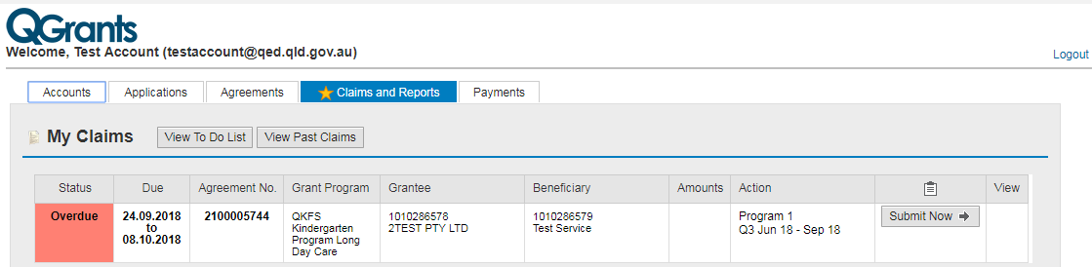

You will be presented with the QGrants claiming screen which outlines the initial nine steps that are required to be completed to submit your claim. You may be required to complete some additional steps based on the answers that you provide or the quarter that you are submitting a claim for. These additional steps will appear automatically when the requirement to complete them is triggered.

## Claim Period

On the Claim Period screen the claim period will be preselected from the drop down menu. Ensure this claim period is correct for the quarterly claim being submitted.

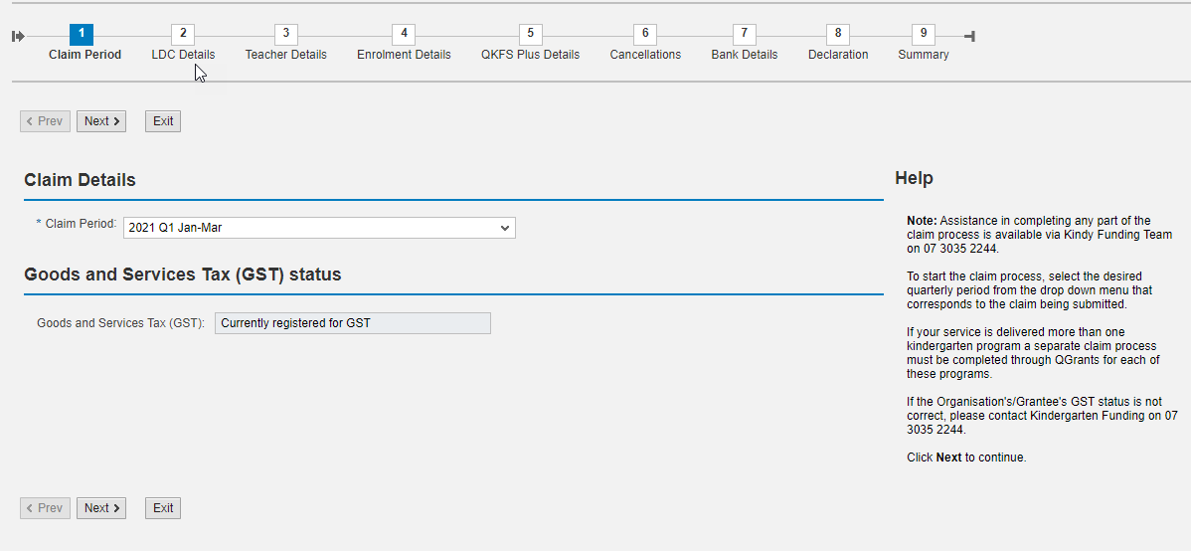

The Goods and Services Tax (GST) status will be prepopulated from the agreement details and cannot be changed as part of the claim process. Contact the Grants Support Team on 07 3035 2244 if the GST status is incorrect or has changed. Do not continue with the claim until the GST status has been corrected.

If all details are correct, click **Next** to continue.

## LDC Details

On the LDC Details screen you are required to provide information about the Kindergarten program that your service has delivered during the claiming period.

*If you have delivered multiple programs in a quarter, you need to submit a separate claim for each program. The Total number of programs delivered in this quarter will need to be the same in each claim and is what allows QGrants to open up additional claims. If you enter 1 program in this field and submit your claim, QGrants will not open additional claims for you.*

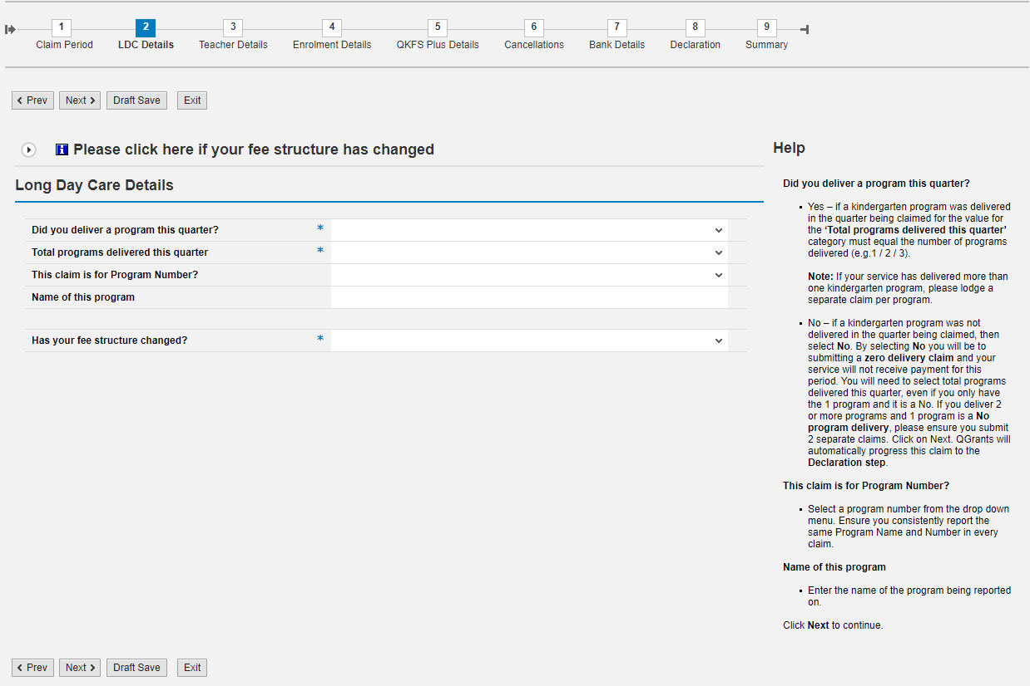

The following mandatory requirements apply:

* If you have delivered a Kindergarten program and answer “YES” to the first question, all five questions are mandatory and must be answered before you can continue with the claim.
* If you have not delivered a Kindergarten program and you answer “NO” to the first question, only the three questions with an asterix beside them are mandatory and must be answered before you can continue with the claim. If you select “NO” on this question, you will skip steps 3-8 when you click Next.

For claiming consistency, the following should be adhered to:

* The number of programs delivered by your service should be the same for the entire year. For example, if your service submits claims for 3 programs in quarter 1, it is expected that you will continue to submit 3 claims for all other quarters in that year. If you reduce the number of programs during the year, you are still required to submit a no program delivery (NIL claim) for that program each quarter of that year.
* Program Names and numbers are to be consistently reported each quarter. For example, if you deliver multiple programs in quarter 1, you are expected to ensure that the program number and the program name are entered the same way in the subsequent quarters.

***Has your fee structure changed?***

* If your fee structure for the Kindergarten program has changed since the previous QKFS claim, you are required to answer “YES” to this question.
* If your fee structure for the Kindergarten program has not changed, you can select “NO” for this question.

*Any services that were KPP approved* ***after 01 January 2021****, answering “YES” to this question will require you to upload evidence of your new fee structure in step 7 of the claim process.*

*For services that were approved* ***prior to******01 January 2021,*** *you are still required to answer “YES” if your fee structure for the Kindergarten program changes, but you are not required to upload evidence of your new fee structure in step 7 of the claim process.*

When all details have been entered correctly, click **Next** to continue.

## Teacher/s Details

On the Teacher Details screen, you are required to provide the names of the qualified Early Childhood Teacher/s (ECT) and the names of any person who is ‘actively working towards’ an ECT qualification who are delivering the kindy program. You may add the names of the other educators/teachers that are assisting in the room, but this is not mandatory.

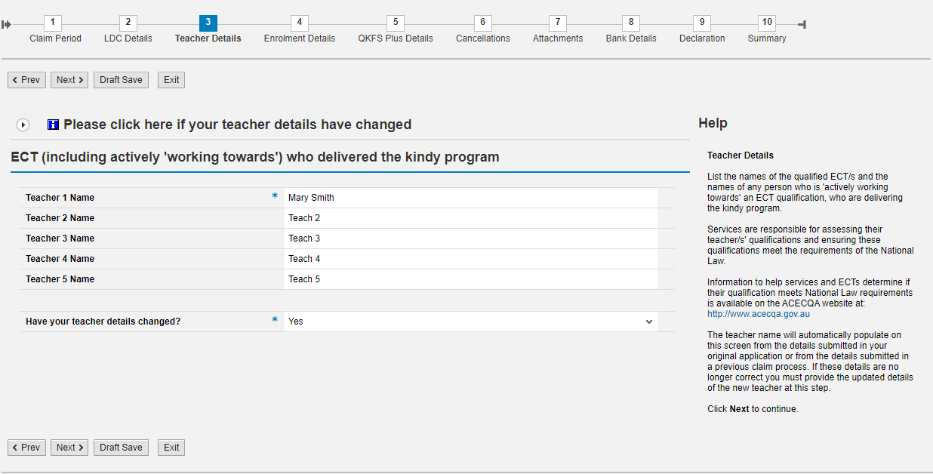

***Have your teacher details changed?***

This question relates to the ECT/s delivering the kindergarten program only.

* If the ECT delivering the Kindergarten program has changed since the previous QKFS claim, you are required to answer “YES” to this question.
* If the ECT delivering the Kindergarten program has not changed since the previous QKFS claim, you select “NO” for this question.

*Any services that were KPP approved* ***after 01 January 2021****, answering “YES” to this question will require you to upload evidence of your new ECTs qualifications and employment in step 7 of the claim process.*

*For services that were approved* ***prior to******01 January 2021,*** *you are still required to answer “YES” if your ECT delivering the Kindergarten program changes, but you are not required to upload evidence of the new ECTs qualifications and employment in step 7 of the claim process.*

If you require some additional explanation about these questions, please refer to the help section on the right side of the QGrants screen.

When all details have been entered correctly, click **Next** to continue.

## Enrolment Details

On the Enrolment Details screen, you are required to provide weekly enrolment data as follows:

* Enrolled children – These are the number of children **enrolled** in the Kindergarten program that meet the QKFS eligibility requirements and a service can count them towards their QKFS funding claim.
* Actual Attendance (in hours) – Calculate the number of hours in total that the enrolled children above attended the Kindergarten program for the week.

When calculating the attendance hours, you cannot include the following in this count:

* + The Long Day Care portion of a child’s day that is before and after the standard Kindergarten program times,
  + Days or times when the Kindergarten program is not being delivered by an ECT ie due to staff illness/absence without replacement,
  + When a child is absent and does not attend the kindergarten program.

Funding for QKFS is still provided based on enrolments, not attendance. The requirement to collect attendance data is for departmental reporting and modelling purposes.

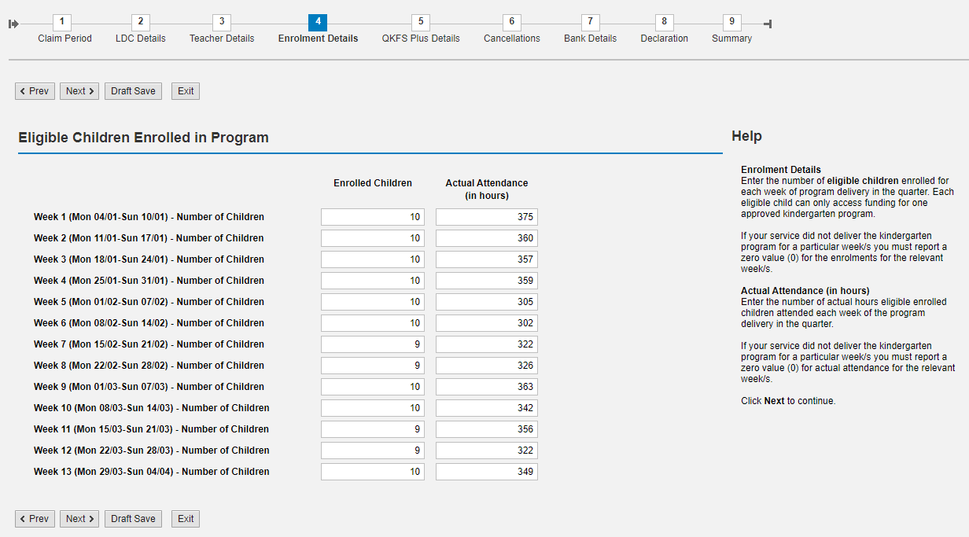

When all details have been entered correctly, click **Next** to continue.

## QKFS Plus Details

On the QKFS Plus Details screen, you are required to provide the quarterly enrolment data as follows:

* Enrolled children – These are the number of children currently or have been **enrolled** in the Kindergarten program that meet the QKFS Plus eligibility requirements and a service can claim QKFS Plus funding on their behalf. Regardless of how many weeks they were enrolled, if they met the eligibility criteria for at least 1 week, they are included and the subsidy is paid to the service in full for that child.
* Actual Attendance (in hours) – Calculate the number of hours in total that the enrolled children above attended the Kindergarten program for the whole quarter.

When calculating the attendance hours, you cannot include the following in this count:

* + The Long Day Care portion of a child’s day that is before and after the standard Kindergarten program times,
  + Days or times when the Kindergarten program is not being delivered by an ECT ie due to staff illness/absence without replacement,
  + When a child is absent and does not attend the kindergarten program.

Funding for QKFS Plus is still provided based on enrolments, not attendance. The requirement to collect attendance data is for departmental reporting and modelling purposes.

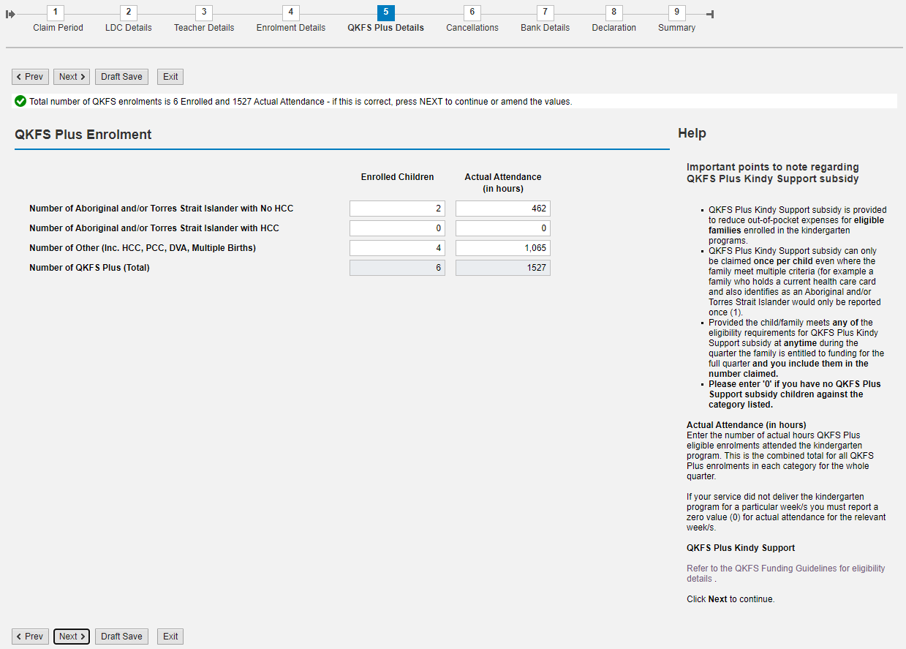

When all details have been entered correctly, click **Next** to calculate the QKFS Plus totals. Review the data to ensure that the totals are correct. If correct, click **Next** again to continue.

If not correct, amend the data and click **Next** to recalculate the totals, then click **Next** again to continue.

## Cancellations

On the Cancellations screen, you are required to provide the number of enrolments that have been cancelled by the Service. You are not required to provide data on cancellations where parents/guardians have requested the cancellation of their child’s enrolment.

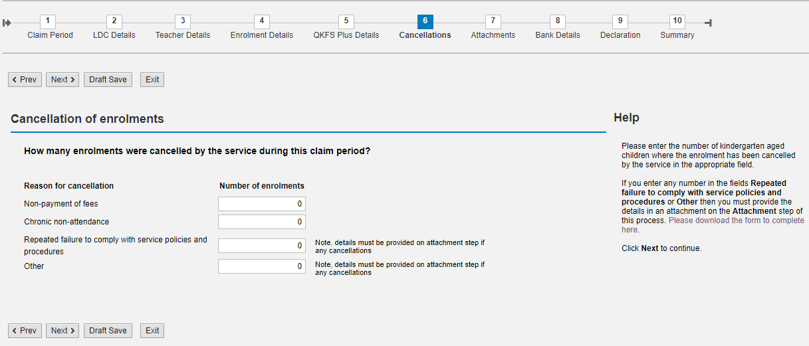

The first two reasons; Non-payment of fees, and Chronic non-attendance do not require further explanation.

If your service cancels an enrolment for failure to comply with service policies and procedures, or any other reasons, you are requried to provide further information.

The form on which to provide this additional information, is downloadable on the right of the QGrants screen.

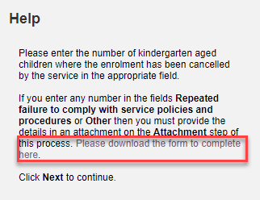 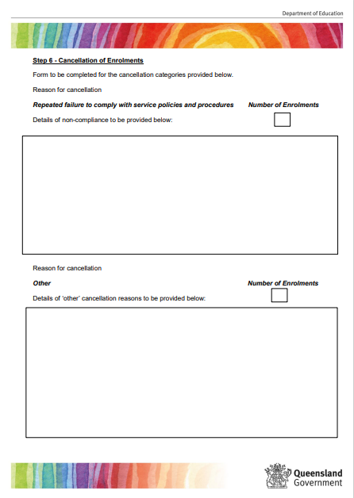

When all details have been entered correctly, click **Next** to continue.

## Attachments

The Attachments step will only appear if you have triggered a requirement to provide additional information. Once this has been triggered and the attachments step is included, you will note that the total number of steps for the claim has now increased to 10.



On the Attachments screen, you will see a list of documentation that is required in order to support certain answers you provided in previous steps of the claim.

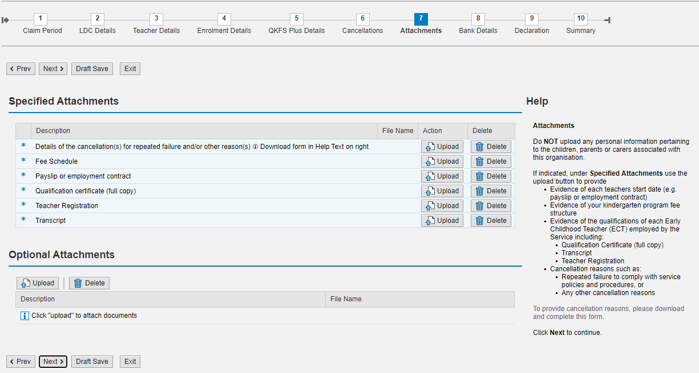

Any documents requested in the Specified Attachments section are mandatory and must be uploaded before you can continue with the claim.

If your service wishes to upload any other documentation to support your claim that is not mandatory, you can upload this in the Optional Attachments section.

To upload a document, click on the Upload button, then click on Choose File and locate the document that you want to upload. Click on OK.

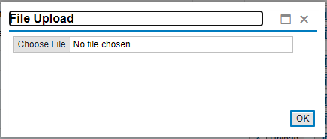

You will note that the document is uploaded with the name of the file displayed.

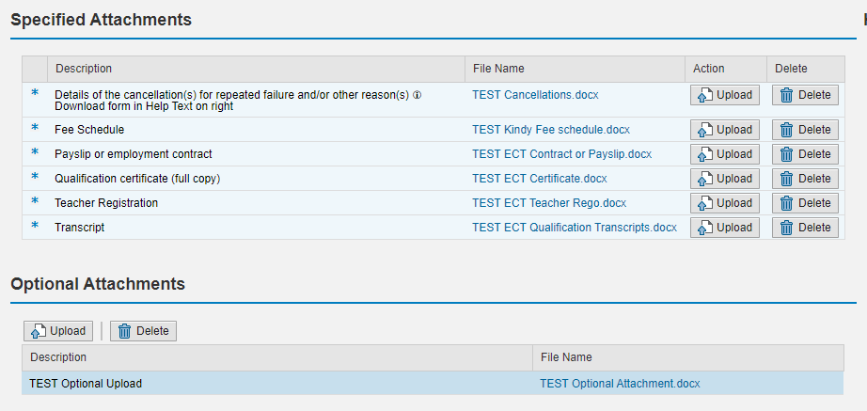

To view the document that you have uploaded, click on the file name.

Follow this process to upload all the documents that have been requested for the claim.

If you need to delete a document, click on the Delete button and click **OK** on the confirmation pop-up.

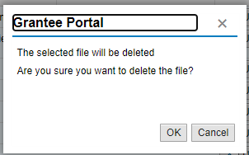

When all have been uploaded, click **Next** to continue.

## Bank Details

On the Bank Details screen, you are required to select the bank account into which the QKFS funding is to be received.

The bank account details that are auto populated on this screen, generate from your original application, and/or any previous QKFS claim.

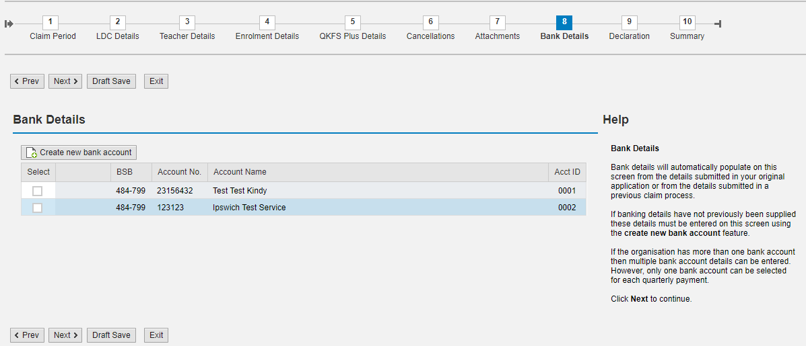

You must select a bank account before you can continue with this claim.

If you have a new Bank account, or the one you wish to receive the funds into is not on this screen, you must create a new bank account using the Create new bank account button.

Only one bank account can be selected for each quarterly payment.

Once you have selected the correct bank account, click **Next** to continue.

## Declaration

On the Declaration screen you must review the Department of Education and the Queensland Government Short Form Terms and Conditions and the QKFS Funding requirements by clicking on the links provided. Each document will open in separate windows. You must click on all the links to view each of the documents to be able to progress.

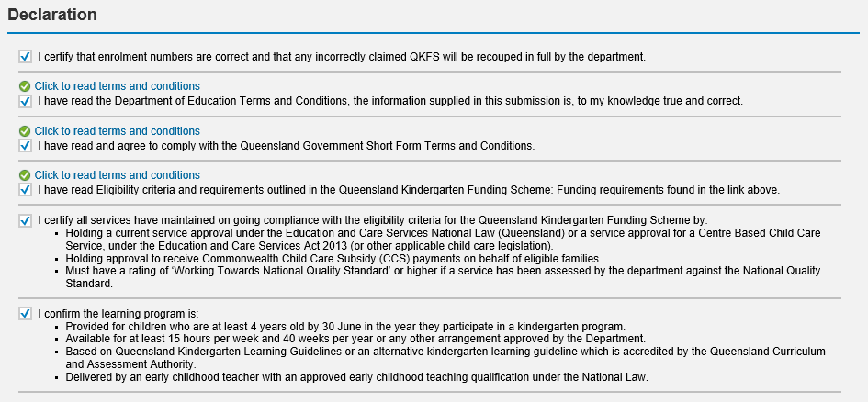

By clicking on the checkboxes you are indicating:

* You have read both terms and conditions;
* You have read the funding requirements;
* You agree you are complying with these terms and conditions and funding requirement; and
* The information supplied in this claim is true and correct.

Click **Next** to continue.

## Summary

On the Summary screen, you will be provided a summary of all the information entered for this claim. Check that the claim is correct before proceeding.

To amend any details entered during this claim process click on the **<Prev** or **Next>** navigation buttons.

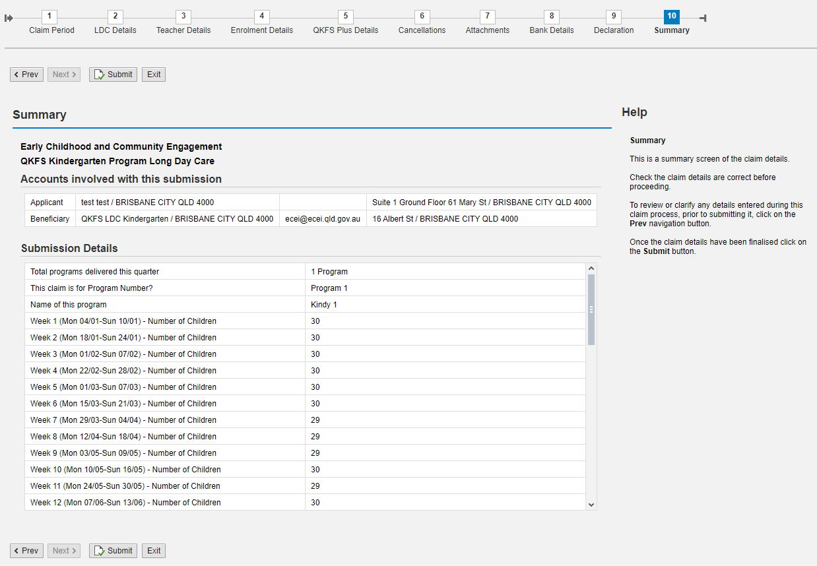

Once you have reviewed all the information and determined that it is correct, click **Submit** button to submit the claim for processing.

Once submitted a copy of the claim will be emailed to you. You can also download and save an electronic copy or print a hard copy of the claim.

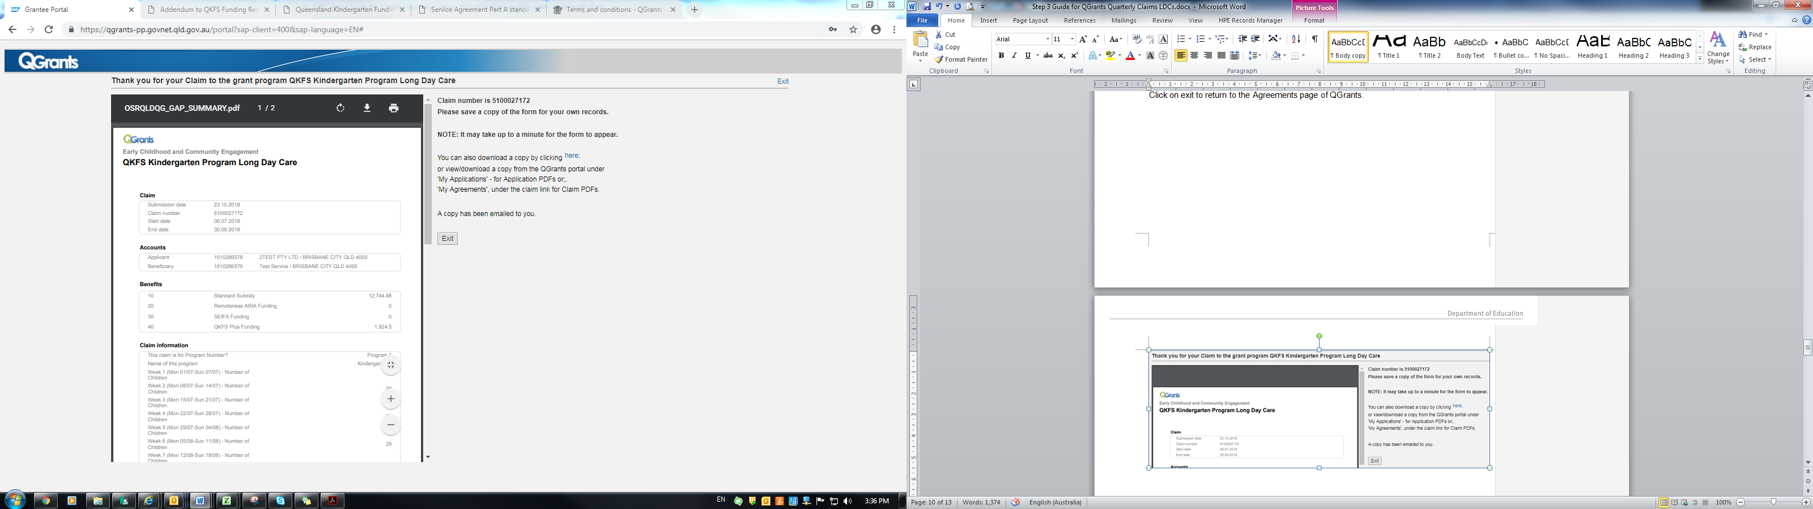

Click on exit to return to the **Claims and Reports** tab of QGrants.

## Transition Statements (Quarter 4 claims only)

The ECT delivering the Kindergarten program is required to provide a Transition Statement for each child enrolled in their program in November each year, in preparation for moving from Kindergarten to Prep.

Kindergarten services are required to use the Kindergarten transition statement template accessible from the QCAA portal: <https://www.qcaa.qld.edu.au/kindergarten/supporting-transition-school>.

The quarter 4 claim submission will require services to provide transition statement information including, the number of statements developed and the number provided to schools with parental consent.

The transition statement step will be available for completion in QGrants for the quarter 4 claiming period only.

# Additional program claims

If your service has delivered multiple programs for the quarter, you are required to submit a separate claim for each program.

Following the steps above for Submitting a quarterly claim, ensure that you enter the total number of programs your service delivered in the LDC Details step to allow QGrants to recognise that your service has multiple claims and allow you to put multiple claims through. Remember that the name of each program needs to be consistent with the program number for all claims in the year.

If you submit your claim with the incorrect number of programs and are not able to submit further claims, please contact the Grants Support Team on 07 3035 2244 so that the claim can be re-opened to allow you to make the necessary amendments.

# Viewing previously submitted claims

To view claims that have been submitted, click on **View Past Claims** to show a list of all claims previously submitted. By clicking on the claim number you can view the claim in detail. You can also download or view a PDF copy of the claim by clicking on the view icon.

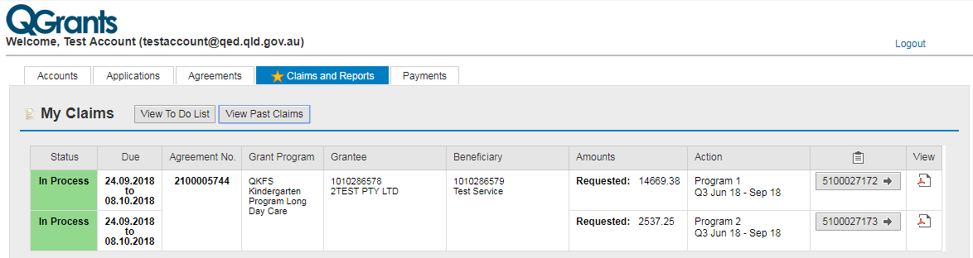

# Claim Status - More Information

When viewing the Claims and Reports tab in QGrants, you may notice that your claim sitting in the “More Information” status.

When the submitted claim is being assessed by a Grants Officer, the claim may be changed to the status of “More Information”. The Grants Officer will contact the service before this status is changed using the contact details listed in QGrants.

Claims with a Status of “More Information” allow the service to go back into the claim and make any necessary changes before the claim can be processed.

If you note that your claim is in this status and are unsure why, please contact the Grants Support Team on 07 3035 2244 so that we can advise what additional information is required.

# Claim Adjustments

Once a claim has been submitted in QGrants, you are unable to make changes to that claim. If you have identified that there are errors in your claim, please follow the steps below:

* The claim has the status of **“In Process”** – Please call the Grants Support Team on 07 3035 2244 and ask that they open the claim up so that you can make changes to the claim in QGrants. Once you have made the necessary changes, you will need to re-submit the claim.
* The claim is in the status of **“Approved”** – The claim cannot be amended by the service in QGrants. Please email the Grants Support Team at [QKFS.LDC@qed.qld.gov.au](mailto:QKFS.LDC@qed.qld.gov.au) to request an adjustment to your claim.

Adjustments to claims that have already been approved and paid to the service, can only be made for the previous quarter. Adjustments to claims prior to the previous quarter, may be accepted at the discretion of the department.

### Requesting your claim adjustment

Print a copy of your claim summary report from QGrants by going to the Claims and Reports tab, and clicking on the View past claims button.

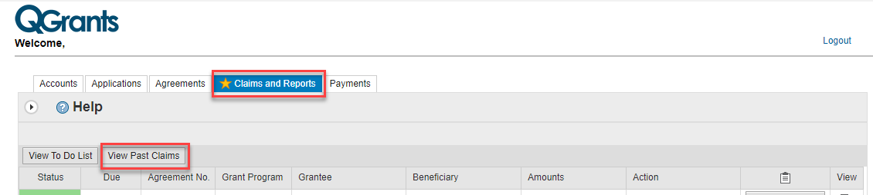

You will find a list of the claims that you have submitted for all of your services. Find the claim that you need to make an adjustment to and click on the pdf icon to view the claim summary.

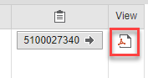

Once you have printed this summary, you can identify the changes that need to be made.

You can do this by crossing out the values that you submitted and writing what they need to be changed to.

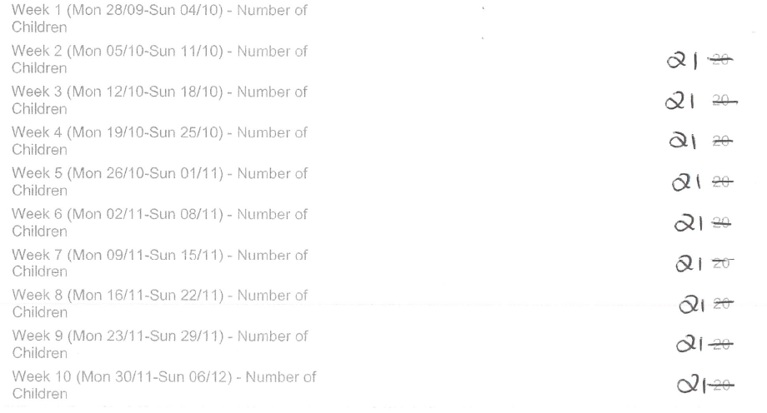

When requesting QKFS Plus changes, please ensure that you identify the changes to the categories as well as the total so that we are able to make the correct changes to the claim.

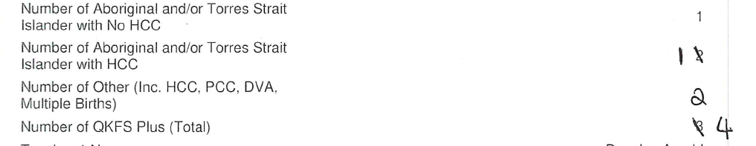

The claim summary can then be scanned and emailed to the Grants Support Team at [QKFS.LDC@qed.qld.gov.au](mailto:QKFS.LDC@qed.qld.gov.au) to request an adjustment to your claim.

If the claim adjustment has resulted in an increase to your original funding amount, the difference will be paid to the same bank account as the original claim within 3-5 business days after the adjustment has been approved.

If the claim adjustment has resulted in a decrease to your original funding amount, an invoice will be issued to the service for payment. When paying the invoice, please ensure that you follow the directions at the bottom so that the payment can be assigned correctly.

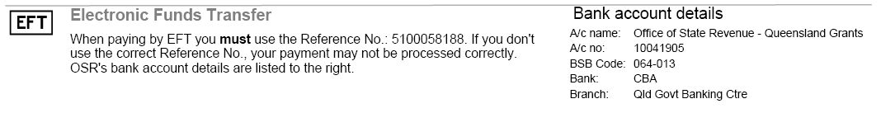

If payment of the invoice is not received before the next quarterly claim is processed, the outstanding amount will be automatically deducted from that payment.