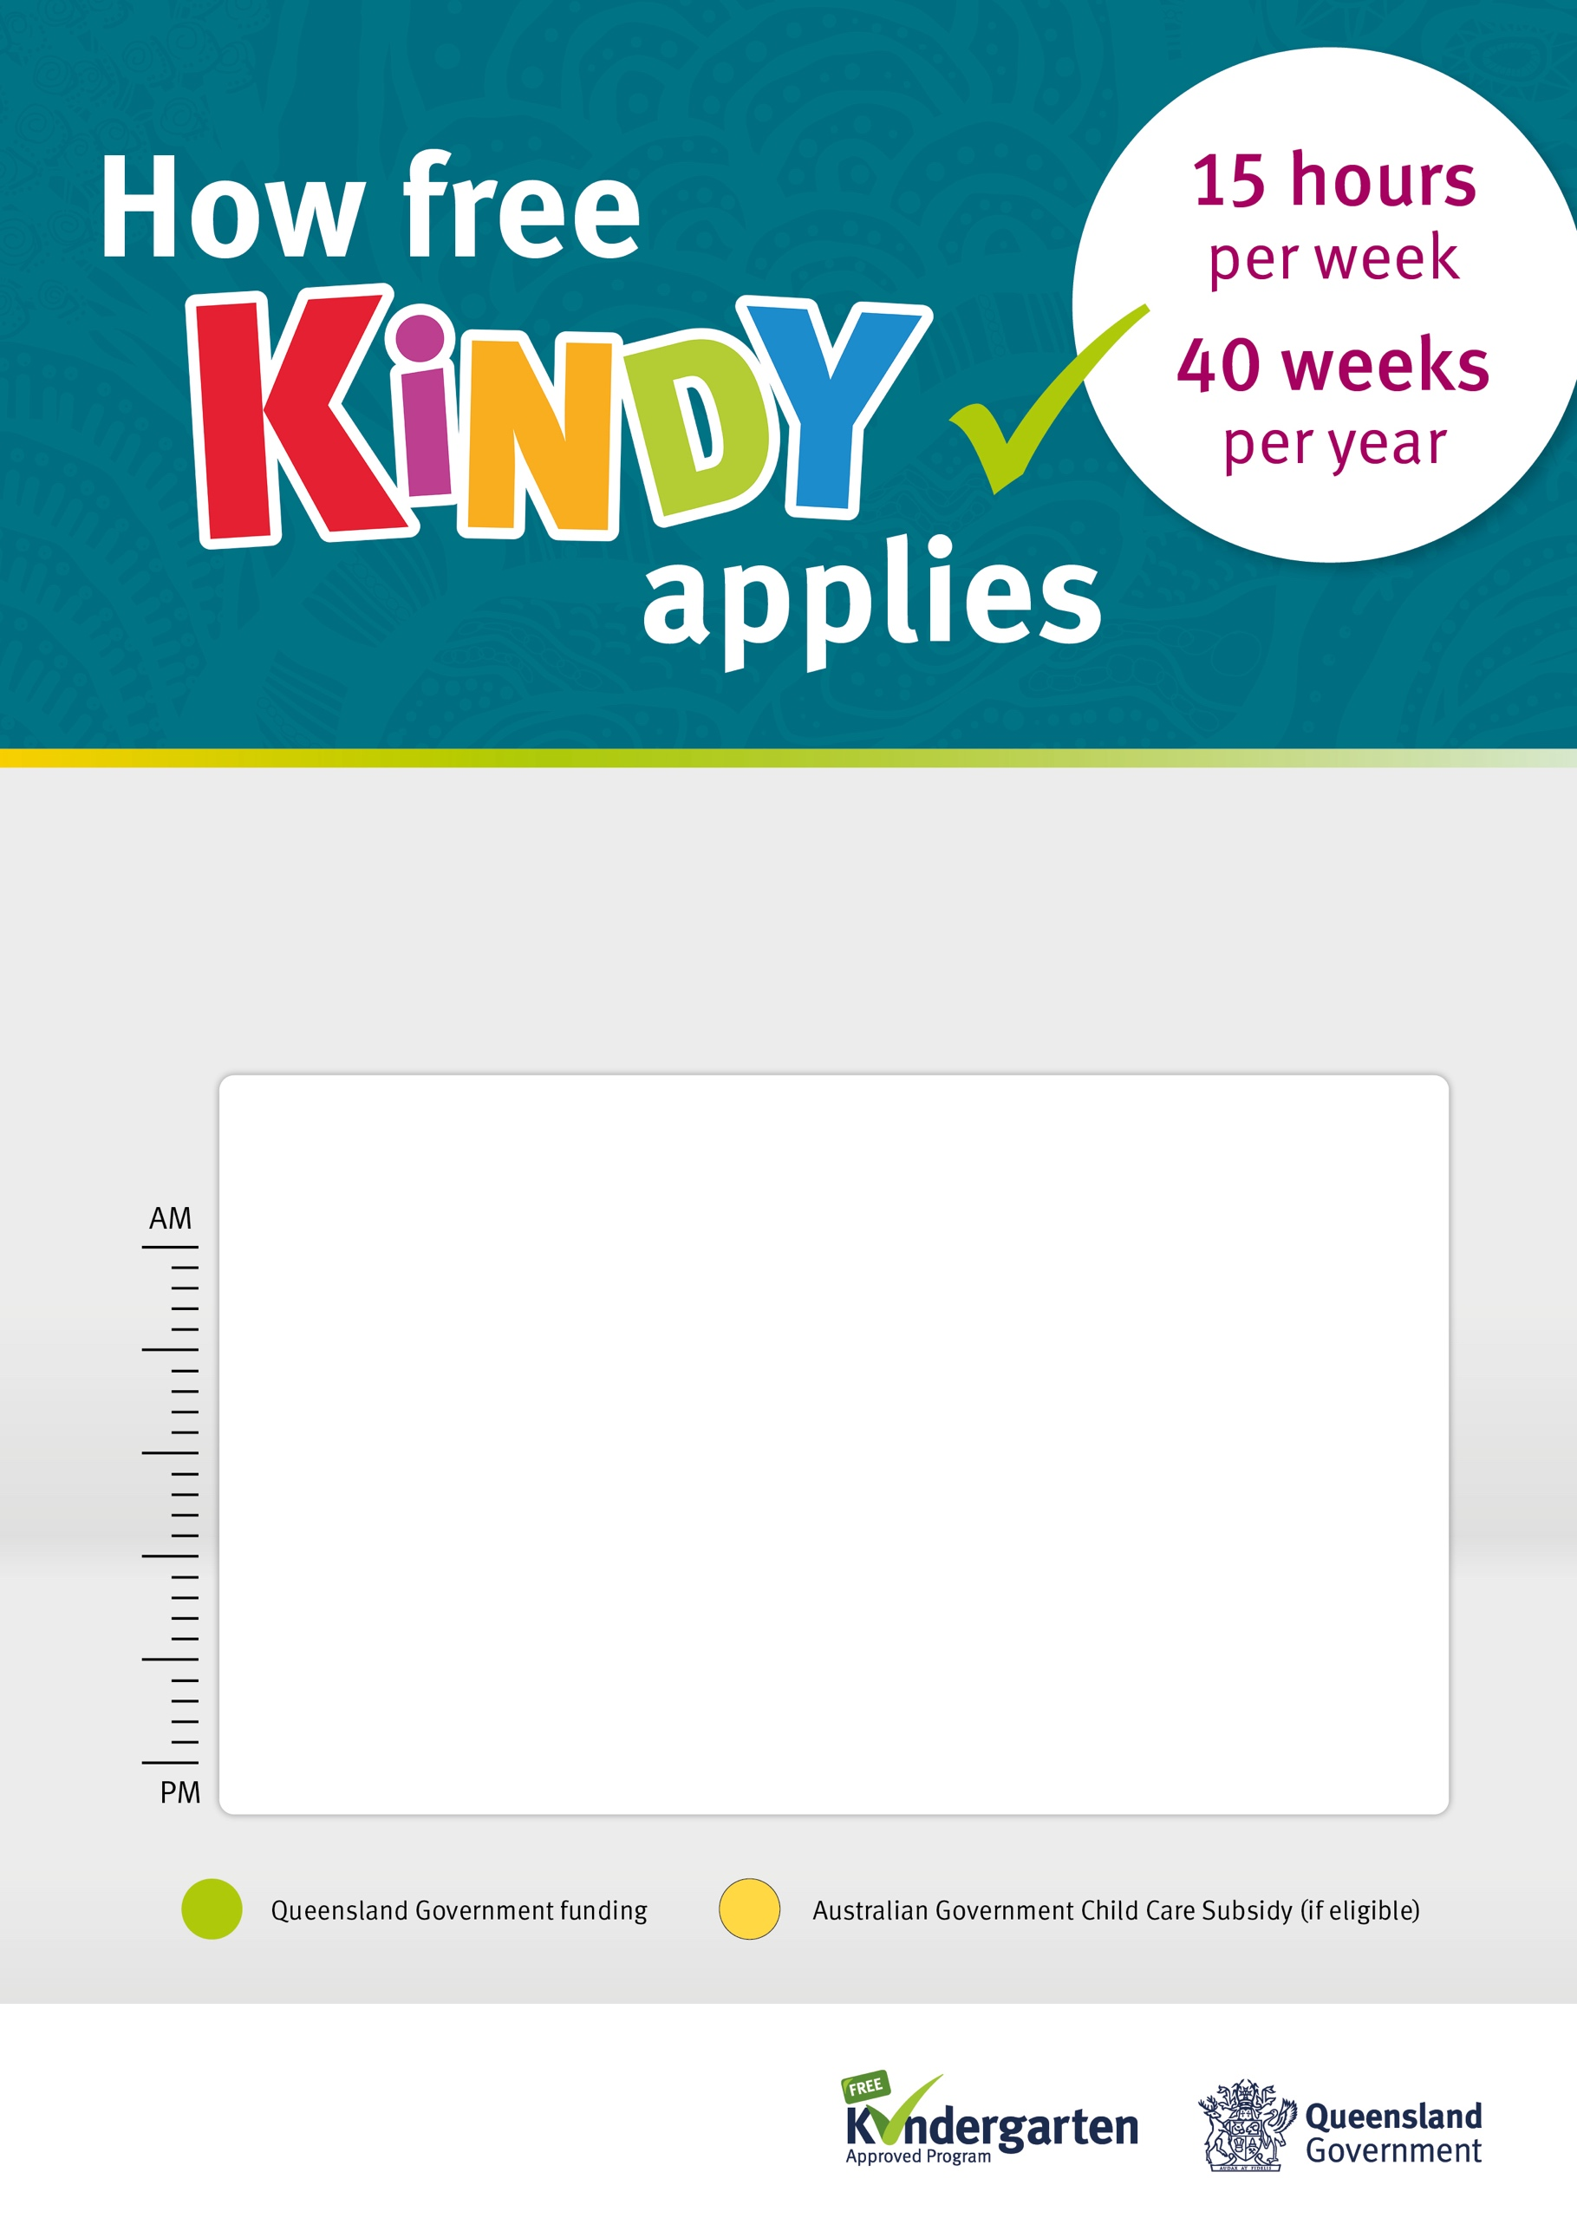

**Wrap-around  
kindy care**

**Wrap-around  
kindy care**

**Wrap-around  
kindy care**

**5 hours**

**Wrap-around  
kindy care**

**5 hours**

**Wrap-around  
kindy care**

**Long day care example**

Kindergarten programs can be provided over two or three days, at a long day care service.

Services may have different offerings such as two 7.5 days or three 5 hour days, across the week. This example shows kindy split across three days as part of a full week at long day care.

**Full day  
of care**

**Full day  
of care**

**Wrap-around  
kindy care**

**5 hours**

**Monday**

Kindergarten   
program is available

**Tuesday**

Kindergarten   
program is available

**Wednesday**

Kindergarten   
program is available

**Thursday**

Kindergarten   
program is available

**Friday**

Kindergarten program is not available

**5 hours**

**5 hours**

**5 hours**