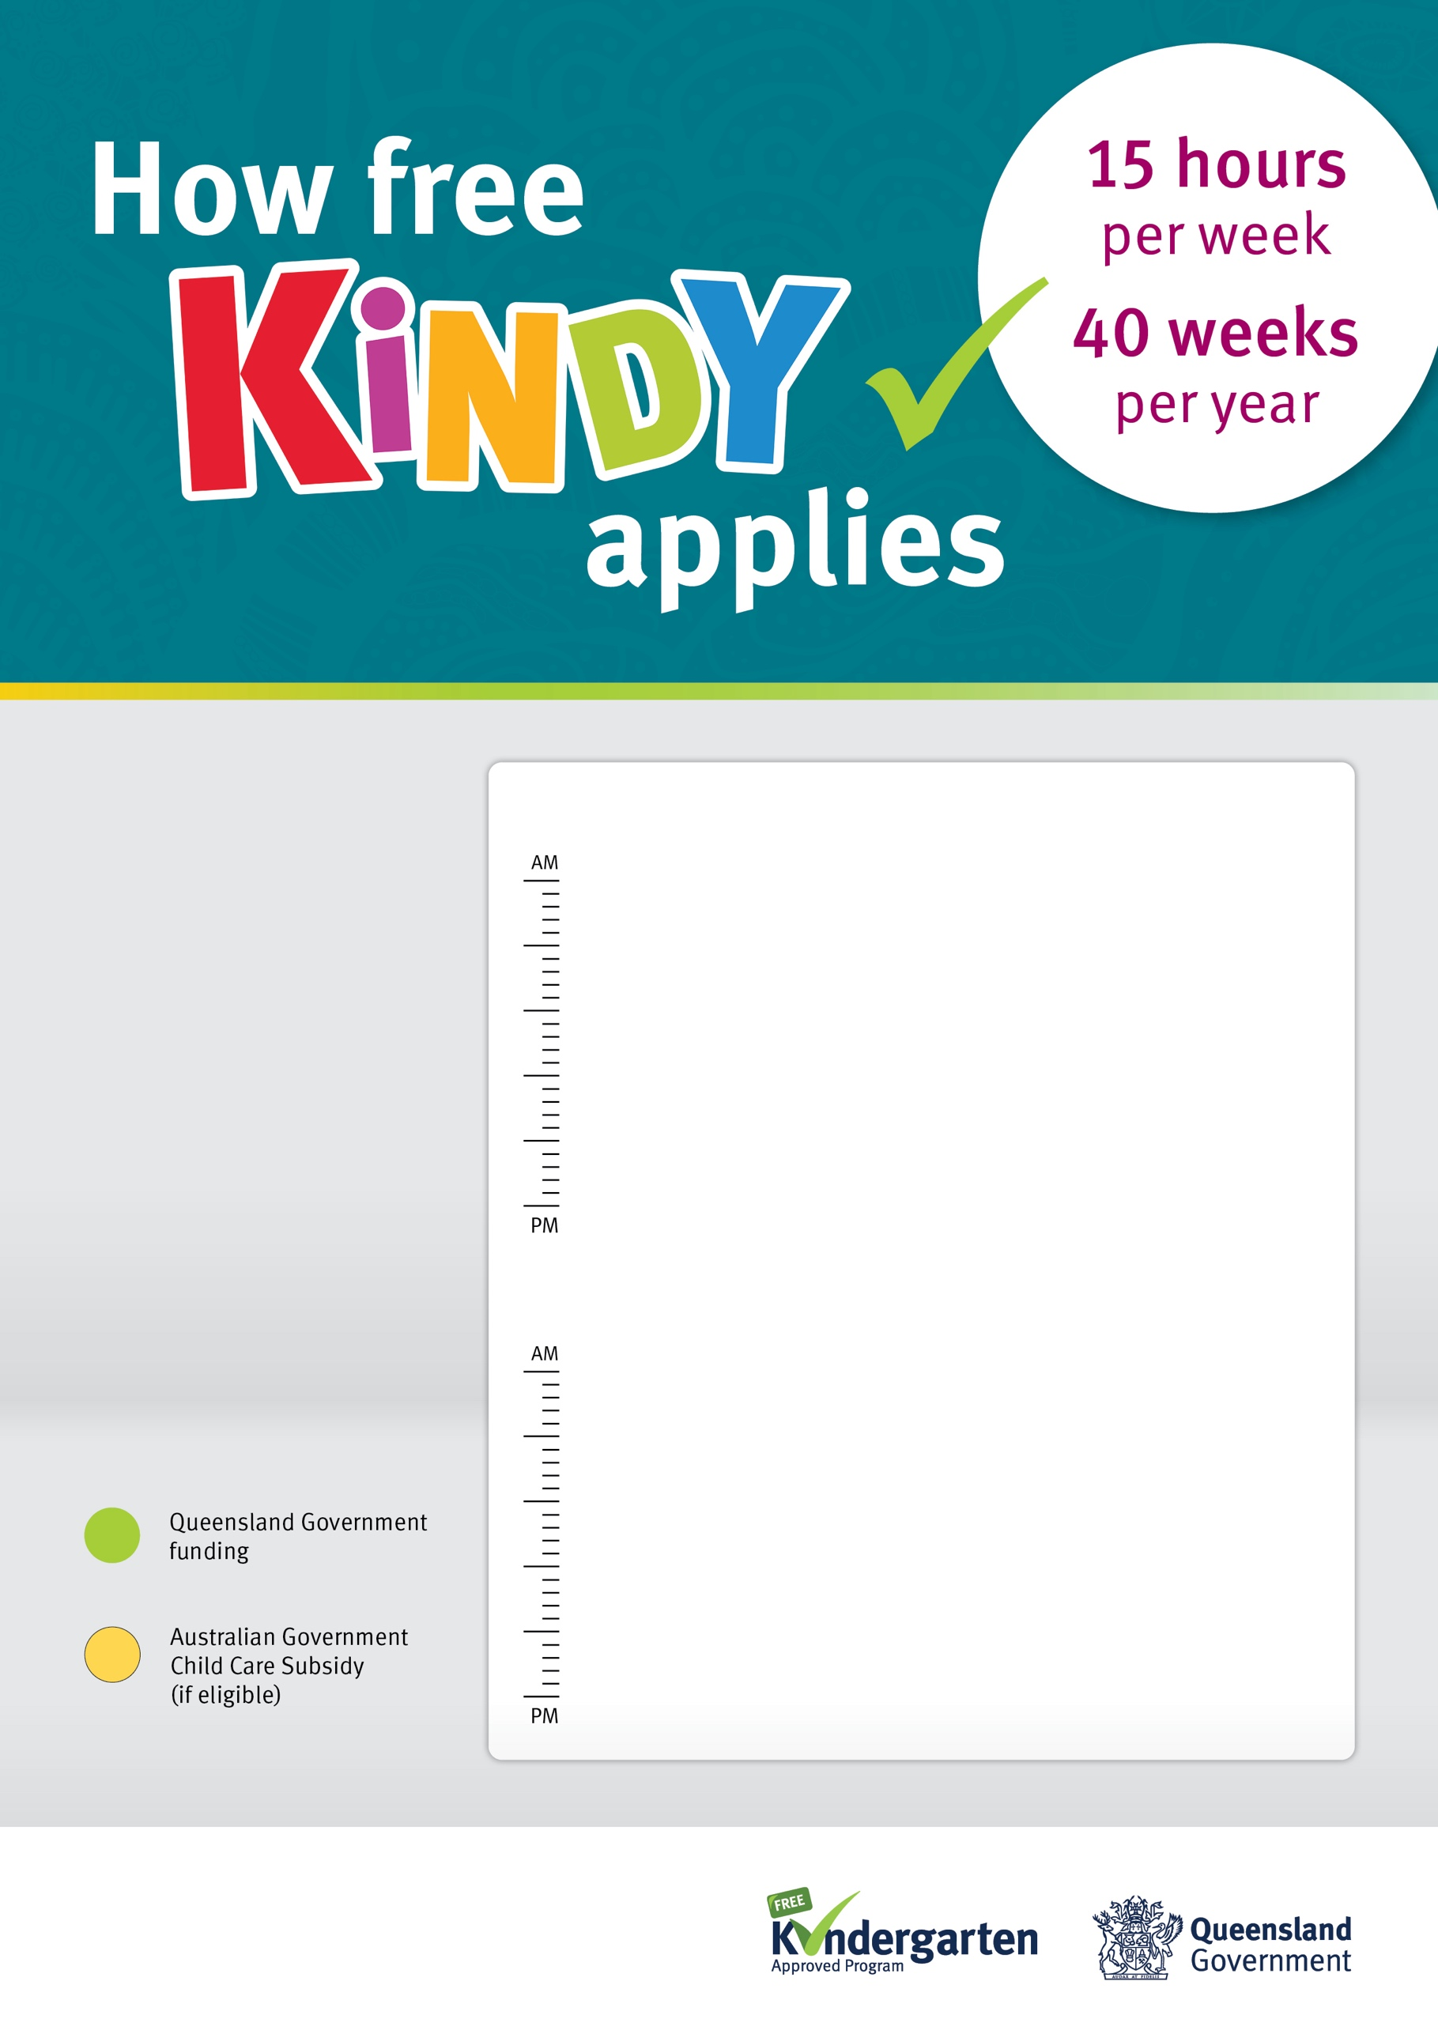~~$~~

**Friday**

Kindergarten program  
is not available

**Thursday**

Kindergarten   
program is available

**Wednesday**

Kindergarten   
program is available

**Tuesday**

Kindergarten   
program is available

**Monday**

Kindergarten program  
is not available

**7.5 hours**

**7.5 hours**

**Wrap-around  
kindy care**

**Wrap-around  
kindy care**

**Wrap-around  
kindy care**

**Wrap-around  
kindy care**

**Full day  
of care**

**Full day  
of care**

**Full day  
of care**

**Friday**

Kindergarten program  
is not available

**Thursday**

Kindergarten   
program is available

**Wednesday**

Kindergarten   
program is available

**Tuesday**

Kindergarten   
program is available

**Monday**

Kindergarten program  
is not available

**5 hours**

**5 hours**

**5 hours**

**Wrap-around  
kindy care**

**Wrap-around  
kindy care**

**Wrap-around  
kindy care**

**Wrap-around  
kindy care**

**Wrap-around  
kindy care**

**Wrap-around  
kindy care**

**Full day  
of care**

**Full day  
of care**

**Service Name Example**

Our kindergarten program can be provided over five days in a ten day fortnight, at this long day care service. Our kindergarten program is available Tuesday to Thursday.

This example shows how a family may choose to enrol in kindy. Kindy is 15 hours per week, 40 weeks per year and is FREE.

**5 hours**