Child Record Collection upload instructions

Overview

The Queensland Department of Education has been partnering with the following child care subsidy system software providers to make the 2024 Census easier for you to complete:

- Child Care Central
- Harmony Web
- HeartBeat4Kidz
- HubWorks! (HubHello!)
- Kangarootime
- Kidsoft
- Kindy Manager
- OWNA
- Qikkids
- Storypark Manager
- Xap and
- Xplor

Funded services will be able to run a report from their administrative systems (after 4 August) and download the required child information necessary for census reporting. You will then be able to directly upload this report into the 2024 Census collection tool.
Your software company will provide information about how to find and create this report. Once you have located your report, please follow steps 1 and 3 of the instructions below which show you how to: check your report against the Census requirements and upload your report directly into the Census collection tool.
If you do not use any of the software listed above or if your software provider does not provide this report: you can submit this information using the DoE supplied template spreadsheet by following the instructions in step 2 below or you can enter the records manually in the Census collection tool.

Step 1 – Read the Child Record Collection checklist
Before you complete or generate your child record collection file please ensure you have referred to the child record upload checklist on the Census webpage. This checklist provides helpful information and tips on how to enter the child records correctly.

Step 2 – Creating your upload file
Services have a number of ways to enter their child information in the Census. These are:
- Directly enter child records strainght into the Census tool, one child at a time;
- Download your data from your enrolment system and upload the file into the Census tool;
- Enter you child information into the DoE spreadsheet and upload this file into the Census tool.
For the purpose of this document is to explain how to upload you completed data into the Census tool.

2.1 Download your child data from your enrolment system

Most childcare management software providers have developed a report that will allow services to upload kindergarten program enrolments into the Census collection tool.
A number of childcare management software providers have supplied the location to download your kindergarten file. Please ensure that all children aged 3 to 6 who are enrolled for at least one hour in your kindergarten program are included in this file. If your software system is not listed then we ask that you contact them directly to locate this file.

Reference period is 29 July to 4 August 2024
Kidsoft Software:
- Go to Reports
- Go to Other
- Go to Child Record Collection Report
- Enter the reference period
Qikkids software:
- Go to Reports
- Go to Miscellaneous
- Go to QLD Government Census Report
- Enter the reference period
Xplor software
- Go to Reports
- Go to QLD Kindy Census Report
- Enter the reference period
OWNA software
- Go to Reports
- Go to Children
- Go to QLD Census Report
- Enter the reference period
This file will either be created or emailed to you depending on your enrolment system.

2.2 Using the DoE excel template

Download and complete the excel template spreadsheet
For those services using the DoE supplied spreadsheet, please complete this step. Those who already have a report exported out of their software system can skip to step 3.

- Download and save the excel template spreadsheet to your desktop from the Child Record Upload section of the Census webpage.
- Enter all information for all children aged 3-6 years who are enrolled in a kindergarten program at your service. Please note: You will be required to use codes rather than text to record this information. E.g. Male should be recorded as 1 and Female as 2. Please refer to the spreadsheet for all data entry requirements.

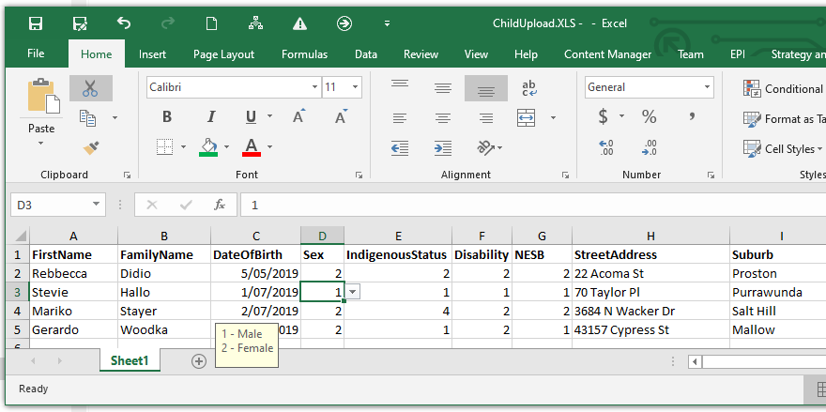

Step 3 – Checking your upload file
- Please ensure that all names and address details are spelt correctly, particularly the suburb where the child resides. This will reduce the number of errors that will need to be corrected later. Ensure that all cells have been enter with the appropriate response. Please consult with the child record upload checklist on the Census webpage to assist you..
- Once you have completed all data you may then save your updated file as an excel or csv file.
- To assist in entering data, the table below shows the information needed in each column.
Column | Description
FirstName | The child's first name
FamilyName | The child's family name
DateOfBirth | The child's date of birth (in the format DD/MM/YYYY)
Sex | The sex of the child
IndigenousStatus | Is this child of Aboriginal and/or Torres Strait Islander descent?
Disability | Is the child diagnosed with a disability or suspected disability or long-term medical condition requiring assistance?
NESB | Is this child from a non-English speaking background?
StreetAddress | The residential street address of this child’s parent/guardian
Suburb | The suburb for the residential street address of this child’s  parent/guardian
PostCode | The postcode for the residential street address of this child’s parent/guardian
State | The state for the residential street address of this child’s  parent/guardian
HoursEnrolledPreSchool | The number of hours this child is enrolled in a kindergarten program in a typical week
HoursAttendedPreSchool | Please enter the number of hours per week (on average) that this child attended the kindergarten program?
PreschoolProgramRepeatIndicator | To the best of your knowledge, prior to this year was this child enrolled in a kindergarten program in this or another service?
HealthCareCard | To the best of your knowledge does this child have a Health Care card?  Also includes Department of Veterans' Affairs Gold Card or White Card, or Australian Government Concession Card.
* All columns MUST contain a response

Step 4 – Upload your data into the Census collection tool
Once you have produced and checked your report, you can upload the file directly into the Census collection tool. Please note that file must be in CSV, XLS or XLSX format.

- Open the Census, navigate to the “Child Details” page and click on the “Import” button as shown below.

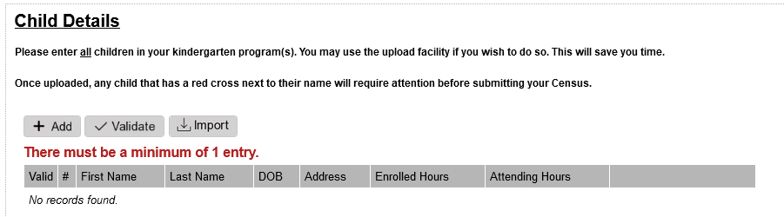

- You will now be asked to locate the relevant file on your computer and select “Open”.

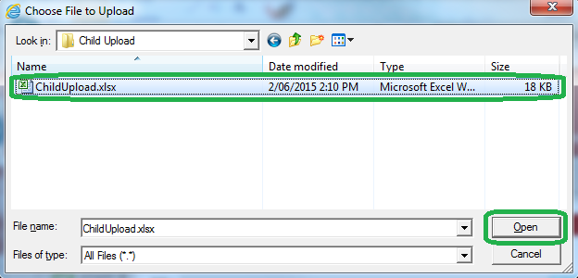

- Once you click open, the collection tool will automatically read the child records into the system and produce an Upload Summary. You may export this information to a file and investigate any issues or import the data and fix the problems in your Census directly.
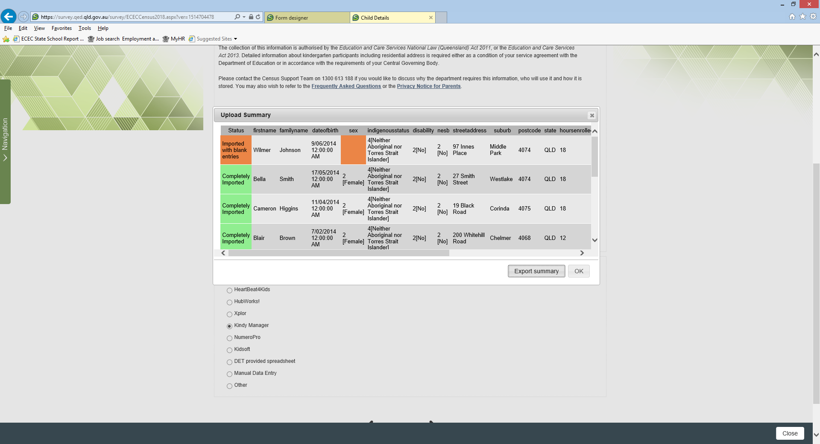
- If an error has occurred with a particular child record, a red cross will appear next to that child’s name. See below.
You will be required to resolve these issues before submitting your Census. These issues may include missing information or incorrect information.
You can correct data for any child simply by clicking on the “Edit” button for that child.
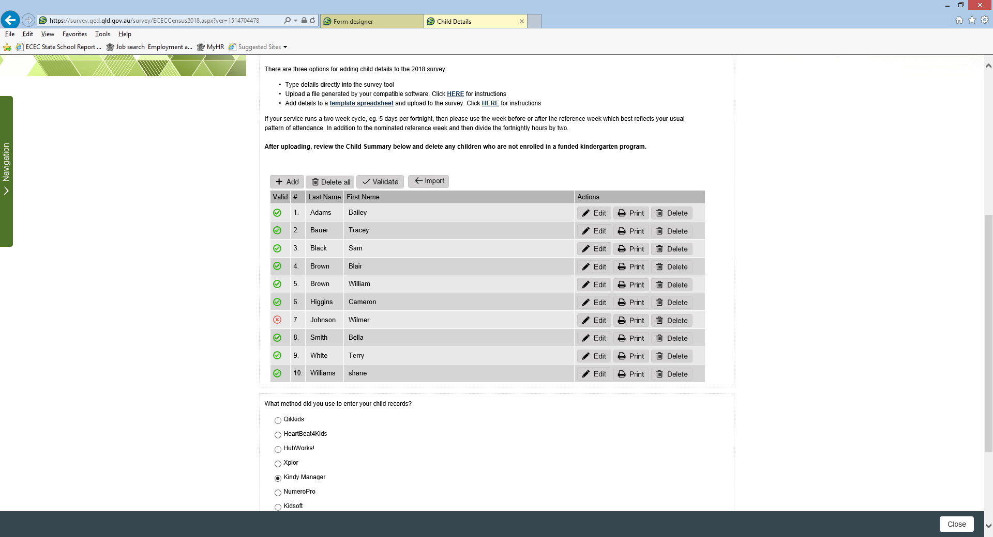
- You also have the ability to delete a single child simply by clicking on the “Delete” button for that child.

- You may also delete all children and start the upload process again by clicking on the “Delete all” button.

